CHURCH CHAT
“Any or all information is subject to change without notification”
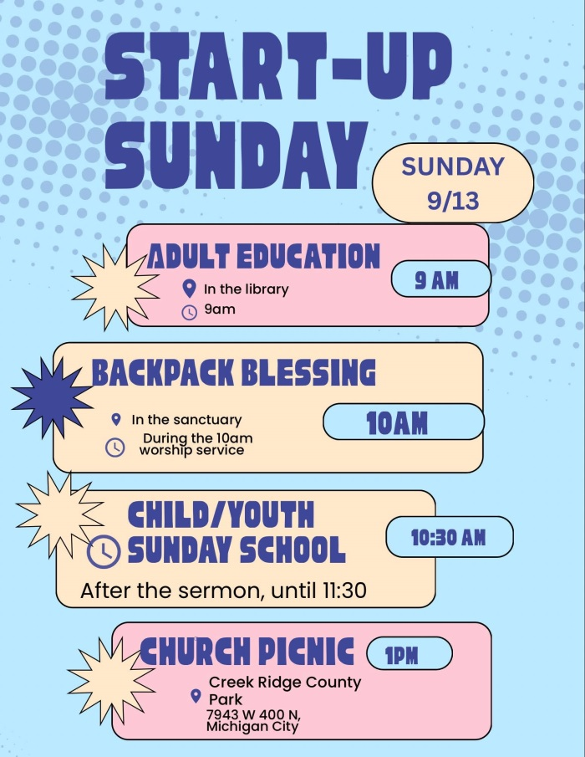


MEETINGS FOR SUMMER BOOK CLUB:
Fridays will be at 11a.m. at Lakeshore Café (Coffee House) located at
444 Wabash Street, Michigan City.
Last meeting for this group will be on October 2nd.

CHANCEL FLOWERS
If you would like to sponsor the Chancel Flowers, which goes to the Children in Need fund, we currently have the following dates available September 27 and October 4. If you have an “annual” date, that is reserved for you. The cost is $35. Please contact the office to check if a date you are interested in is available.
Thank you. Diane Yettaw, Administrative Assistant

ART SHOW BY LAURA KITTLE
Lubeznik Center for the Arts Sept 01-Sept 31
Opening Reception on Sept 04 from 5-7 PM


FINANCIALS



ATTENTION ATTENDEES
The signup sheets are located on the Edith Boyd Lounge door.
PLEASE sign up…we need signatures.
If you have any questions, please see Pastor Ericka.

PW SUMMER PROJECT
We are collecting powder drink mix for the shelter on 8th Street. Place them on the table near the coat racks.
Thank you, Carol G and Debbie L

FEATURED ARTIST
A reminder that Teresina Pavel’s art work is still on display in our Edith Boyd Lounge.
Take a moment to check out her work.

UPCOMING CLASSES
If you or someone you know might be interested in attending classes, please contact Gail at 219-575-3654 or GailsCrafts2025@gmail.com for additional information or to sign up.

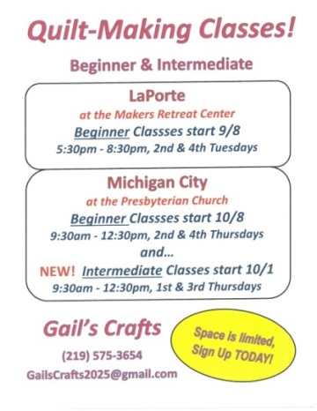

† † †
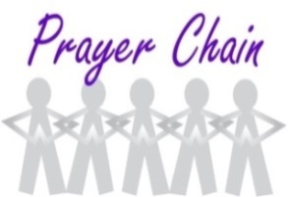

For prayer requests
Contact Jeanette Tyrrell at
219tyrrell@gmail.com

† † †

Rev. Dr. Ericka Parkinson Kilbourne
Mobile – 219-380-6566
Office – 219-879-4501 Ext 203
Fax – 219-879-4503
E-mail erickapk@fpcmicity.org

† † †

Diane Yettaw, Office Administrator
Office – 219-879-4501 Ext 201
Fax – 219-879-4503
E-mail – dyettaw@fpcmicity.org

† † †

Web Site Address – http://www.fpcmicity.org
YouTube – First Presbyterian Church Michigan City
Facebook – First Presbyterian Church Michigan City
WiFi password: 1holyGod!

† † †

