CHURCH CHAT
“Any or all information is subject to change without notification”

FINANCIALS
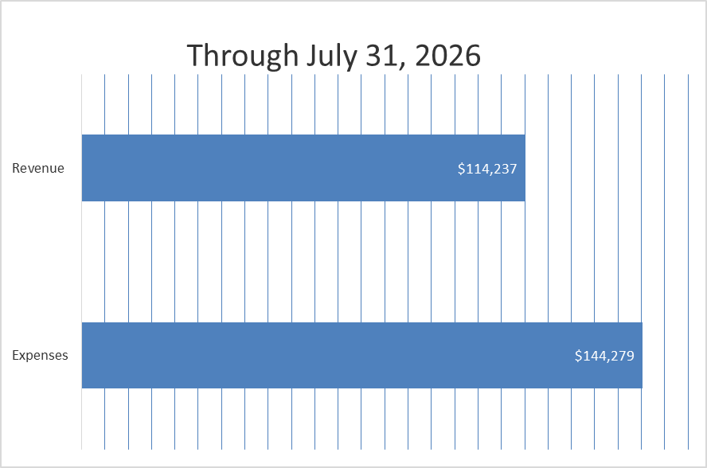

CHANCEL FLOWERS
If you would like to sponsor the Chancel Flowers, which goes to the Children in Need fund, we currently have the following dates available August 23 & 30, and October 4. If you have an “annual” date, that is reserved for you. The cost is $35. Please contact the office to check if a date you are interested in is available.
Thank you. Diane Yettaw, Administrative Assistant


MEETINGS FOR SUMMER BOOK CLUB:
- Sunday, August 9th at 3p.m. Location to be announced-possible date change
- Sunday, August 16th at 3p.m. at Melanie Ledgerwood home. Maximum Six
- Sunday, August 23rd at 3p.m. at Melanie Ledgerwood home. Maximum Six
- Sunday, August 30th at 3p.m. at Melanie Ledgerwood home. Maximum Six
Melanie’s address: 205 Bluebird Place, Trail Creek

- Fridays will be at 11a.m. at Lakeshore Café’ (Coffee House) located at 444 Wabash Street, Michigan City.

Sign up form is located on the door of the Edith Boyd Lounge.
If you are planning on attending, PLEASE SIGN UP

We are out of books but you can purchase one from Amazon.





ALL-CHURCH PICNIC
Time flies and our annual All-Church picnic will be here before we know it. Again this year the picnic will be at Creek Ridge Park (Prairie Shelter) on September 13th at 1:00 p.m. In the near future a signup sheet will be on the door of the Edith Boyd Lounge.
BUT in the meantime be sure to save the date!!
Hope to see all there.

PW SUMMER PROJECT
We are collecting bottles of salad dressing (ranch and French) for the shelter on 8th Street. Place them on the table near the coat racks.
Thank you
Carol G and Debbie L

ATTENTION PRESBYTERIAN WOMAN
The All-Circle meeting will be on Wednesday, September 9, 2026 at 10:00 a.m. to 2:00 p.m. in the Edith Boyd Lounge. Pastor Ericka will present the new Bible Study, “United Through Christ, Bound to Each Other”. Please bring a sack lunch. Drinks will be provided. See you then.
Carol Garrett

FEATURED ARTIST
A reminder that Teresina Pavel’s art work is still on display in our Edith Boyd Lounge.
Take a moment to check out her work.

FOOTLIGHT PLAYER THEATRE
Are you looking for a fun activity this afternoon? Why not head on over to Footlight Players Theatre to watch their new play, a comedy called "The Foreigner." It is directed by our own Laura Meyer with Sue Ransom being the assistant director. (She also has a small part in the play.) The play starts at 2:00 pm and cost is $17. The play will run August 13-16 too...Thursday and Friday at 7 PM and Saturday and Sunday at 2 PM. Hope to see you there.

† † †


For prayer requests
Contact Jeanette Tyrrell at
219tyrrell@gmail.com

† † †

Rev. Dr. Ericka Parkinson Kilbourne
Mobile – 219-380-6566
Office – 219-879-4501 Ext 203
Fax – 219-879-4503
E-mail erickapk@fpcmicity.org

† † †

Diane Yettaw, Office Administrator
Office – 219-879-4501 Ext 201
Fax – 219-879-4503
E-mail – dyettaw@fpcmicity.org

† † †

Web Site Address – http://www.fpcmicity.org
YouTube – First Presbyterian Church Michigan City
Facebook – First Presbyterian Church Michigan City
WiFi password: 1holyGod!

† † †

