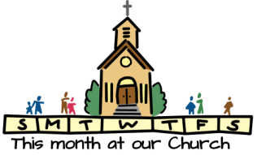
CHURCH CHAT
“Any or all information is subject to change without notification”

CHANCEL FLOWERS
If you would like to sponsor the Chancel Flowers, which goes to the Children in Need fund, we currently have the following dates available October 4. If you have an “annual” date, that is reserved for you. The cost is $35. Please contact the office to check if a date you are interested in is available.
Thank you. Diane Yettaw, Administrative Assistant

ATTENTION PRESBYTERIAN WOMEN
The All-Circle meeting will be on Wednesday, September 9, 2026 at 10:00 a.m. to 2:00 p.m. in the Edith Boyd Lounge. Pastor Ericka will present the new Bible Study, “United Through Christ, Bound to Each Other”. Please bring a sack lunch. Drinks will be provided. See you then.
Carol Garrett

ALL-CHURCH PICNIC


Time flies and our annual All-Church picnic will be here before we know it. Again this year the picnic will be at Creek Ridge Park (Prairie Shelter) on September 13th at 1:00 p.m.
The signup sheet is on the door of the Edith Boyd Lounge.
PLEASE take the time to let us know how many will be in your party and what you are bringing. We want to have a variety of things to choose from and letting us know how many will be attending helps us plan so we are don’t come up short.
Hope to see all there.


MARK YOUR CALENDARS FOR 3B
The next session for 3B will begin on Tuesday, September 8th from 10 a.m. to 11 a.m.
This session will run through November 24th.
Come join us as we “buzz” our way through this session!
If you have any questions, please see either Alice Yacullo or Lois Miley.

PW SUMMER PROJECT
We are collecting bottles of salad dressing (ranch and French) for the shelter on 8th Street. Place them on the table near the coat racks.
Thank you, Carol G and Debbie L

MEETINGS FOR SUMMER BOOK CLUB:
- Sunday, August 30th at 3p.m. at Melanie Ledgerwood home. Maximum Six
This is the last meeting for this group at Mel’s
Melanie’s address: 205 Bluebird Place, Trail Creek
- Thursday, September 10 at 11a.m. in the Edith Boyd Lounge
This will be the last group meeting

- Fridays will be at 11a.m. at Lakeshore Café (Coffee House) located at
444 Wabash Street, Michigan City.
Last meeting for this group will be on October 2nd.



FEATURED ARTIST
A reminder that Teresina Pavel’s art work is still on display in our Edith Boyd Lounge.
Take a moment to check out her work.
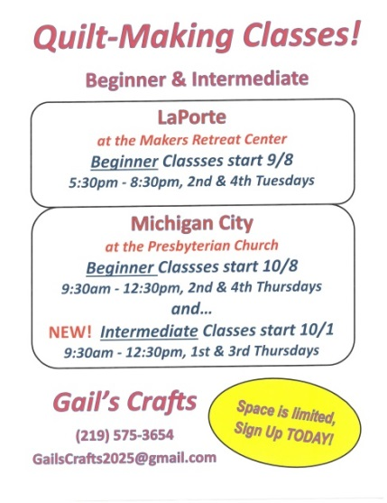

UPCOMING CLASSES
If you or someone you know might be interested in attending classes, please contact Gail at 219-575-3654 or GailsCrafts2025@gmail.com for additional information or to sign up.

† † †
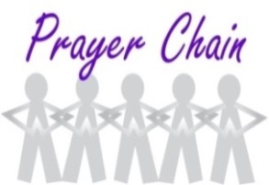

For prayer requests
Contact Jeanette Tyrrell at
219tyrrell@gmail.com

† † †

Rev. Dr. Ericka Parkinson Kilbourne
Mobile – 219-380-6566
Office – 219-879-4501 Ext 203
Fax – 219-879-4503
E-mail erickapk@fpcmicity.org

† † †

Diane Yettaw, Office Administrator
Office – 219-879-4501 Ext 201
Fax – 219-879-4503
E-mail – dyettaw@fpcmicity.org

† † †

Web Site Address – http://www.fpcmicity.org
YouTube – First Presbyterian Church Michigan City
Facebook – First Presbyterian Church Michigan City
WiFi password: 1holyGod!

† † †

