CHURCH CHAT
“Any or all information is subject to change without notification”


Books are in! If you would like to purchase one the cost is $15.00. Please see Diane in the office.


ANNUAL BUILDING AND GROUNDS CLEANING & GROUNDS WORK
We have had a great start to our annual spring cleanup. Thank you to all who have helped in getting things done, but there are still tasks that need to be completed. Please use the link or QR code below for the online signup sheet. There is also a paper copy on the door of the Edith Boyd Lounge.
Please consider helping. If you have questions, please see Amy or Alice.

Thank you. Amy McDaniel, Building & Grounds Chair
https://www.signupgenius.com/go/20F0549A8A622A4FA7-63964402-2026

CHANCEL FLOWERS
If you would like to sponsor the Chancel Flowers, which goes to the Children in Need fund, we currently have the following dates available July 19, July 27, August 16, 23 & 30, and October 4. If you have an “annual” date, that is reserved for you. The cost is $35. Please contact the office to check if a date you are interested in is available.
Thank you. Diane Yettaw, Administrative Assistant





ALL-CHURCH PICNIC
Time flies and our annual All-Church picnic will be here before we know it. Again this year the picnic will be at Creek Ridge Park (Prairie Shelter) on September 13th at 1:00 p.m. In the near future a signup sheet will be on the door of the Edith Boyd Lounge.
BUT in the meantime be sure to save the date!!
Hope to see all there.

FEATURED ARTIST
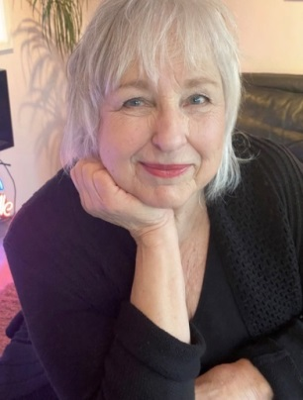
Teresina Pavel
Teresina holds an M.S. in Education, with an endorsement in Art Education and Early Childhood Development. Teresina has used Art Therapy techniques with children in domestic violence shelters and those hospitalized with chronic health issues, helping them express their hope, anger and fears. Her 40-year career also included developing and coordinating art programs for school age children and teaching classes at Ivy Tech College regarding childhood development and creativity.
Upon retirement, Teresina has redefined herself from advocacy roles to that of an artist. She continues to support others through involvement with the Lubeznik Center’s Art Association (A3), and the Marshall J. Gardner Center for Arts.
“What I want to express through my art has evolved. Years ago, moved by the wonders of nature, I simply tried to capture its beauty. Now, with increased threats to our environment, my art is often driven by contradictory feelings…fear of what is happening to our world combined with faith that the force of life will continue”.
“I find a sense of peace creating images that brings order and balance to what could be chaos.”

FRANCISCAN HEALTH MICHIGAN CITY

Tina Hoffmann is a Faith Community Health Coordinator with Franciscan Health. She also facilitates multiple types of suicide prevention and mental health courses. We are hosting an Applied Suicide Intervention Skills Training (ASIST) August 26-27, 2026 at Franciscan Health Michigan City. We believe that we will need support of the Faith Communities to help reduce suicide outcomes. We know people are still in the churches and we want to support those that are supporting the community.

Applied Suicide Intervention Skills Training (ASIST) is a 2 day workshop that helps support growth identifying someone at risk for suicide, asking directly about suicide and then working through how to have an intervention conversation and safety plan development. We discuss the barriers to talking about suicide whether it ourselves or others including personal beliefs. This class is scenario, practice focused, supportive growth and evidence based. ASIST is considered a best practice curriculum by the national Suicide Prevention Resource Center. This community-based class is for everyone not limited to any one profession.
Franciscan Health Michigan City
3500 Franciscan Wy, Michigan City, IN 46360
8:30am-5:00pm both days required. $25 registration fee will cover lunch for both days.
Registration link: https://afspindianaasistaug11.attendease.com/ (Flyer is on the bulletin board)

If you have any questions, please feel free to reach out. Thank you for sharing with your faith community, because together we can build a suicide safer community.

Thank you,
Tina Hoffmann
Faith Community Health Coordinator
Franciscan Health
(317) 528.6609 W
Tina.Hoffmann@franciscanalliance.org

There are flyers on the table under the bulletin board outside of the Edith Boyd Lounge

† † †
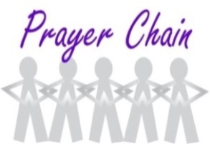

For prayer requests
Contact Jeanette Tyrrell at
219tyrrell@gmail.com

† † †

Rev. Dr. Ericka Parkinson Kilbourne
Mobile – 219-380-6566
Office – 219-879-4501 Ext 203
Fax – 219-879-4503
E-mail erickapk@fpcmicity.org

† † †

Diane Yettaw, Office Administrator
Office – 219-879-4501 Ext 201
Fax – 219-879-4503
E-mail – dyettaw@fpcmicity.org

† † †

Web Site Address – http://www.fpcmicity.org
YouTube – First Presbyterian Church Michigan City
Facebook – First Presbyterian Church Michigan City
WiFi password: 1holyGod!

† † †

