CHURCH CHAT
“Any or all information is subject to change without notification”



EASTER EGG HUNT
The annual Easter egg hunt is today right after the service!


VOLUNTEER OPPORTUNITY
Are you looking for a fulfilling way to serve your church community? Would you find joy in keeping organized records of session minutes and congregational statistics? We are now in an active search for a new Clerk of Session. And if you choose to step up to the task, you have the great opportunity to learn from our most recent Clerk, Laura Kittle, and also Alice Yacullo, who served before her. You would not be alone! Please prayerfully consider serving the congregation in this way. If you have any questions, you can direct them to Pastor Ericka, Laura Kittle, or Alice Yacullo.

MISSION COMMITTEE
The committee is collecting shampoo and conditioner for the YMCA care closet.
Thank you in advance for your donation.

PW PROJECT
During the month of March until after Easter we are collecting boxes of Kleenex and powdered drink mix for the overnight shelter. Thanks for your generosity.
Carol Garrett
Coordinating Moderator


ONE GREAT HOUR OF SHARING
A brochure with information and different ways to give is included in today’s bulletin. There are envelopes for giving in the pews and on the usher’s table. Thank you, Mission Committee
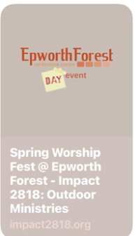
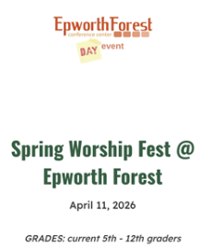
EPWORTH FOREST CONFERENCE CENTER DAY EVENT
On April 11, our youth (grades 5-12) are invited to Epworth Forest for a Spring Worship Fest. This will give our youth an opportunity to become accustomed to the space where we will be going to summer camp! Not only will we participate in exciting worship, but activities include crate climbing, hatchet throwing, monkey climbing, and more! Please speak with Jennifer Casper for more information.


LIGHTS
As a commitment to care for our earth and with the ever-rising cost of NIPSCO, we are asking that you PLEASE turn lights off when you are exiting a room at the end of your meeting/gathering. Thank you.

CHANCEL FLOWERS
We have the following dates available if you would like to sponsor the Chancel Flowers in honor or memory of someone or something. The cost is $35.00 and the money goes to our Children in Need fund. We have April 26 available. If you would like one of these dates or have additional questions, please contact me in the church office. I will post dates for upcoming months in the near future.
Thank you, Diane Yettaw, Administrative Assistant

† † †


For prayer requests
Contact Brian Spiece at
jspiece@hotmail.com

† † †

Rev. Dr. Ericka Parkinson Kilbourne
Mobile – 219-380-6566
Office – 219-879-4501 Ext 203
Fax – 219-879-4503
E-mail erickapk@fpcmicity.org

† † †

Diane Yettaw, Office Administrator
Office – 219-879-4501 Ext 201
Fax – 219-879-4503
E-mail – dyettaw@fpcmicity.org

† † †

Web Site Address – http://www.fpcmicity.org
YouTube – First Presbyterian Church Michigan City
Facebook – First Presbyterian Church Michigan City
WiFi password: 1holyGod!

† † †

