CHURCH CHAT
“Any or all information is subject to change without notification”


VOLUNTEER OPPORTUNITY
Are you looking for a fulfilling way to serve your church community? Would you find joy in keeping organized records of session minutes and congregational statistics? We are now in an active search for a new Clerk of Session. And if you choose to step up to the task, you have the great opportunity to learn from our most recent Clerk, Laura Kittle, and also Alice Yacullo, who served before her. You would not be alone! Please prayerfully consider serving the congregation in this way. If you have any questions, you can direct them to Pastor Ericka, Laura Kittle, or Alice Yacullo.

MISSION COMMITTEE
The committee is collecting shampoo and conditioner for the YMCA care closet.
Thank you in advance for your donation.

PW PROJECT
During the month of March until after Easter we are collecting boxes of Kleenex and powdered drink mix for the overnight shelter. Thanks for your generosity.
Carol Garrett
Coordinating Moderator

CHANCEL FLOWERS
We have the following dates available if you would like to sponsor the Chancel Flowers in honor or memory of someone or something. The cost is $35.00 and the money goes to our Children in Need fund. We have April 26 available. If you would like one of these dates or have additional questions, please contact me in the church office. I will post dates for upcoming months in the near future.
Thank you, Diane Yettaw, Administrative Assistant

GRADUATION BULLETIN
If you have a child, grandchild or family member who will be graduating this year and would like them included in our graduation bulletin, you will need to have their photo and bio emailed to me on or before May 18th at dyettaw@fpcmicity.org
If you have questions, please contact me. Thank you, Diane Yettaw, Administrative Assistant.


RECYCLE BINS
We have three recycle totes in the hallway by the women’s bathroom. You will notice they are now LABELED for what we would like put into them.
- One is for cans and bottles only. Please make sure the containers are empty with the labels and bottle tops removed and they need to be rinsed out.
- Another is for paper only
- The last one is for cardboard only
Thank you for helping us by sorting your recyclables.
Building & Grounds Committee

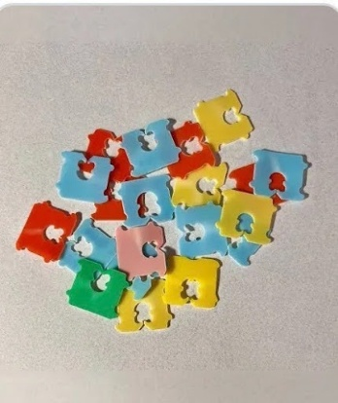


Do you keep your bread tabs? Bring them here and we will take them for recycling to the LaPorte County Solid Waste District! Especially this month, we are using them for our table at the Earth Month Extravaganza. There is a canvas box in the entryway. Thank you!

LIGHTS
As a commitment to care for our earth and with the ever-rising cost of NIPSCO, we are asking that you PLEASE turn lights off when you are exiting a room at the end of your meeting/gathering. Thank you.

† † †


For prayer requests
Contact Brian Spiece at
jspiece@hotmail.com

† † †

Rev. Dr. Ericka Parkinson Kilbourne
Mobile – 219-380-6566
Office – 219-879-4501 Ext 203
Fax – 219-879-4503
E-mail erickapk@fpcmicity.org

† † †

Diane Yettaw, Office Administrator
Office – 219-879-4501 Ext 201
Fax – 219-879-4503
E-mail – dyettaw@fpcmicity.org

† † †

Web Site Address – http://www.fpcmicity.org
YouTube – First Presbyterian Church Michigan City
Facebook – First Presbyterian Church Michigan City
WiFi password: 1holyGod!

† † †

