CHURCH CHAT
“Any or all information is subject to change without notification”

FINANCIALS
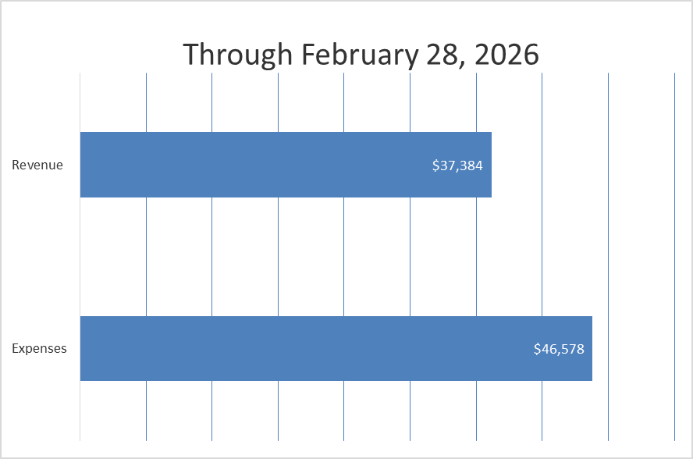

LILY ORDERS
Order forms are available by the usher’s table. The cost this year is $10.00 per plant and you will be able to take yours after worship on April 5th. Please be sure to check the box at the bottom of the form to let us know if you will or will not be taking your plant(s)
Deadline to order and pay for your lily will be on March 29th.
If you have any questions, please contact the office. Thank you.



EASTER BREAKFAST
Join us Easter Sunday for Breakfast from 8:30 a.m. to 9:30 am.
The “food” sign-up sheet is on the door of the Edith Boyd Lounge.
Hope to see you there!!


VOLUNTEER OPPORTUNITY
Are you looking for a fulfilling way to serve your church community? Would you find joy in keeping organized records of session minutes and congregational statistics? We are now in an active search for a new Clerk of Session. And if you choose to step up to the task, you have the great opportunity to learn from our most recent Clerk, Laura Kittle, and also Alice Yacullo, who served before her. You would not be alone! Please prayerfully consider serving the congregation in this way. If you have any questions, you can direct them to Pastor Ericka, Laura Kittle, or Alice Yacullo.

MISSION COMMITTEE
The committee is collecting shampoo and conditioner for the YMCA care closet.
Thank you in advance for your donation.

PW PROJECT
During the month of March until after Easter we are collecting boxes of Kleenex and powdered drink mix for the overnight shelter. Thanks for your generosity.
Carol Garrett
Coordinating Moderator

CHANCEL FLOWERS
We have the following dates available if you would like to sponsor the Chancel Flowers in honor or memory of someone or something. The cost is $35.00 and the money goes to our Children in Need fund. In April the available dates are April 19 and April 26. If you would like one of these dates or have additional questions, please contact me in the church office. I will post dates for upcoming months in the near future.
Thank you, Diane Yettaw, Administrative Assistant

JOIN US FOR A LENTEN STUDY 2026
SAILBOAT CHURCH BY JOAN S. GRAY

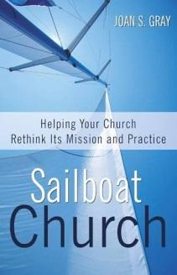

WEEKLY STUDY GROUPS FOR SAILBOAT CHURCH:
- March 18th Wednesday 8pm Hacienda with Pastor Ericka
- March 19th, Thursday 11am after 3B with Alice Yacullo and
Lois Miley
- March 20th , Friday 11AM Lakeshore Coffee with Pastor Ericka
- March 21st, Saturday at Peggy’s house 1406 York St. MC with
Peggy McAnally and Michele Bartels
Books are available online at amazon.com
FORTY DAYS OF PRAYER
For a church to learn to sail, we need to be willing to consider what it would be to become sailors. We invite you to join us in using the guide to Forty Days of Prayer found at the end of Gray's book. We will also be posting this prayer practice daily through Lent. Where will the Holy Spirit take us in this thoughtful study? How can you be part of this prayer and study opportunity?


ONE GREAT HOUR OF SHARING
A brochure with information and different ways to give is included in today’s bulletin. There are envelopes for giving in the pews and on the usher’s table.
Thank you, Mission Committee



LIGHTS
As a commitment to care for our earth and with the ever-rising cost of NIPSCO, we are asking that you PLEASE turn lights off when you are exiting a room at the end of your meeting/gathering. Thank you.

† † †
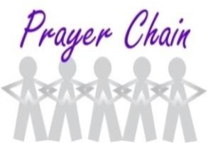

For prayer requests
Contact Brian Spiece at
jspiece@hotmail.com

† † †

Rev. Dr. Ericka Parkinson Kilbourne
Mobile – 219-380-6566
Office – 219-879-4501 Ext 203
Fax – 219-879-4503
E-mail erickapk@fpcmicity.org

† † †

Diane Yettaw, Office Administrator
Office – 219-879-4501 Ext 201
Fax – 219-879-4503
E-mail – dyettaw@fpcmicity.org

† † †

Web Site Address – http://www.fpcmicity.org
YouTube – First Presbyterian Church Michigan City
Facebook – First Presbyterian Church Michigan City
WiFi password: 1holyGod!

† † †

