CHURCH CHAT
“Any or all information is subject to change without notification”

VOLUNTEER OPPORTUNITY

Are you looking for a fulfilling way to serve your church community? Would you find joy in keeping organized records of session minutes and congregational statistics? We are now in an active search for a new Clerk of Session. And if you choose to step up to the task, you have the great opportunity to learn from our most recent Clerk, Laura Kittle, and also Alice Yacullo, who served before her. You would not be alone! Please prayerfully consider serving the congregation in this way. If you have any questions, you can direct them to Pastor Ericka, Laura Kittle, or Alice Yacullo.

ATTENTION ELDERS, DEACONS, NOMINEES, AND SHEPHERDING FRIENDS!
The Outreach Committee would like to meet with you after church today (Feb. 8) to distribute revised Shepherding lists and review the Shepherding guidelines attached to your leadership position. Please go straight to the undercroft after service so that we can begin no later than 11:10. We will have coffee downstairs along with treats for you. We’re looking forward to sharing with you again.

JOIN US FOR A LENTEN STUDY 2026
SAILBOAT CHURCH BY JOAN S. GRAY

STUDY GROUPS FOR SAILBOAT CHURCH:
Starting dates:
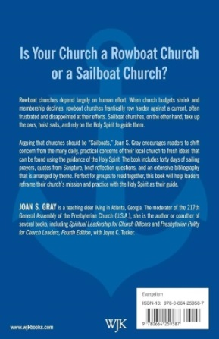
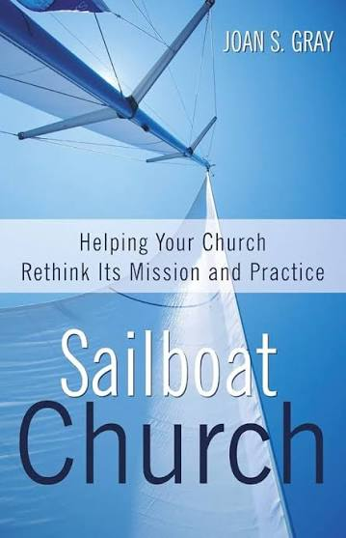
- Feb. 18, Wednesday 8pm Zorn Brewery with
Pastor Ericka
- Feb. 19, Thursday 11am after 3B with Alice Yacullo
and Lois Miley
- Feb. 20th, Friday 11AM Lakeshore Coffee with
Pastor Ericka
- Feb. 21st, Saturday at Peggy’s house 1406 York St. MC with Peggy McAnally and Michele Bartels
- On zoom, date and time TBD depending on preference of attendees with Rev. Doreen Sterba Dezur
Books are available online at amazon.com or can be arranged with Diane in the church office. We will also have a few copies available to be borrowed. Please arrange borrowing with Pastor Ericka

FORTY DAYS OF PRAYER
For a church to learn to sail, we need to be willing to consider what it would be to become sailors. Beginning February 18th, we invite you to join us in using the guide to Forty Days of Prayer found at the end of Gray's book. We will also be posting this prayer practice daily through Lent. Where will the Holy Spirit take us in this thoughtful study? How can you be part of this prayer and study opportunity?

LIGHTS
As a commitment to care for our earth and with the ever rising cost of NIPSCO, we are asking that you PLEASE turn lights off when you are exiting a room at the end of your meeting/gathering. Thank you.

2025 GIVING STATEMENTS
If you have not received and would like your 2025 giving statement, please contact me in the office by phone or email. I will be happy to send it to you by USPS mail or email, whichever is best for you. In the last few years, we have printed all of the statements and had them available for you at the usher’s table (there are a few there this year), but we found out that not many were taken so we are going to try this way to save on paper, ink, envelopes and time. If you have any questions or concerns, please contact me.
Thank you. Diane Yettaw, Administrative Assistant.

PW PROJECT
During the months of January and February we are collecting bottles of salad dressing for the overnight shelter. Thanks for your generosity.
Carol Garrett
Coordinating Moderator

YOU ARE INVITED
SEE FLYER ON BULLETIN BOARD
First United Methodist Church would like you to join them for their “last” Valentine Tea on Saturday, February 14th at 1p.m. This event is open to everyone and it is their gift to the community. There is no fee involved. They just want to have an afternoon filled with great memories of their last tea. The event will be at held at 121 E. 7th Street, Michigan City, Indiana.



For prayer requests
Contact Brian Spiece at
jspiece@hotmail.com

† † †

Rev. Dr. Ericka Parkinson Kilbourne
Mobile – 219-380-6566
Office – 219-879-4501 Ext 203
Fax – 219-879-4503
E-mail erickapk@fpcmicity.org

† † †

Diane Yettaw, Office Administrator
Office – 219-879-4501 Ext 201
Fax – 219-879-4503
E-mail – dyettaw@fpcmicity.org

† † †

Web Site Address – http://www.fpcmicity.org
YouTube – First Presbyterian Church Michigan City
Facebook – First Presbyterian Church Michigan City
WiFi password: 1holyGod!

† † †

