**CHURCH CHAT**

“Any or all information is subject to change without notification”



**THE CHANCEL FLOWERS**

We have open dates October 12, and November 23. If you are interested in any of these dates, please contact the office. The cost is $35.00.

**STATEMENT FROM THE FEATURED ARTIST-SHARRON OTT**

While using the circus as a metaphor for life, I contemplate the way that an artist attempts to stop time and preserve moments in visual images.

I combine graphite, paper, and acrylic paint to form the richly textured pieces on stretched canvases. Thank you for visiting my display. Sharron Ott.

Please take a moment to visit Sharron’s art hanging in the Edith Boyd Lounge.

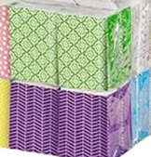**OUTREACH NEEDS**

We are almost out of individual tissue packets. If you would like to contribute a package, please give them to the Sunday usher or any member of the Outreach committee-Michele, Judy, Marilyn, or Peggy. Thank you for your help.

**PW PROJECT OF THE MONTH**

Thank you for your contributions of salad dressings.

In October we are collecting napkins and Kleenex for the Nest Community Shelter.

**HELP NEEDED WITH COFFEE HOUR**

Our 2025 Coffee Hour sign-up chart is posted on the Edith Boyd Lounge door, ready for you along with your family, friends, or committee to pick a date to sponsor coffee hour. Remember, it doesn’t have to be extravagant. Coffee, a drink for the kids, and a treat is all that’s needed. Most of the year is covered by the Women’s Circles, Deacons, and the Mission Committee but every other third Sunday and the fifth Sundays need volunteers. It would be really great if one group would volunteer for all the 5th Sundays, there are 4. If you are willing to do this, see Jeanette Tyrrell. In the meantime please consider serving your fellow congregants by signing up for a coffee hour Sunday.

**HAPPENING IN OUR AREA**

**IMMANUEL LUTHERAN CHURCH**

🎨 **Calling All Crafters!**  
 We are hosting a **Craft Fair** on **Saturday, November 8**, from **9:00 a.m. to 2:00 p.m.**

in our Fellowship Hall.

We’re currently seeking talented artisans and creative individuals to showcase their handmade goods and unique creations. If you or someone you know would like to participate, we’d love to hear from you!

To register or for more details, contact Lori Dobkins at 219-575-1506

**A FLYER IS ON THE BULLETIN BOARD BY THE GARDEN DOOR**

† † †

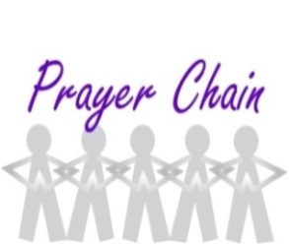

For prayer requests

Contact Brian Spiece at

[jspiece@hotmail.com](mailto:jspiece@hotmail.com)

† † †

Rev. Dr. Ericka Parkinson Kilbourne

Mobile – 219-380-6566

Office – 219-879-4501 Ext 203

Fax – 219-879-4503

E-mail [erickapk@fpcmicity.org](mailto:erickapk@fpcmicity.org)

† † †

Diane Yettaw, Office Administrator

Office – 219-879-4501 Ext 201

Fax – 219-879-4503

E-mail – [dyettaw@fpcmicity.org](mailto:dyettaw@fpcmicity.org)

† † †

Web Site Address – <http://www.fpcmicity.org>

YouTube – First Presbyterian Church Michigan City

Facebook – First Presbyterian Church Michigan City

WiFi password: 1holyGod!

† † †

