CHURCH CHAT
“Any or all information is subject to change without notification”

REMEMBER NOVEMBER 2ND
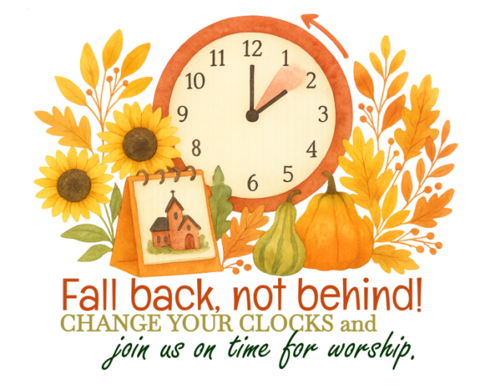


PW PROJECT OF THE MONTH
Thank you for your contributions of salad dressings.
In October we are collecting napkins and Kleenex for the Nest Community Shelter.

HAPPENING IN OUR AREA

FREE CPR CLASSES
Michigan City Fire Department is offering free CPR classes on the following Saturdays. All classes are from 9:00 a.m. until noon:
November 8 at the Salvation Army
November 15 at the Fire Department’s Administration Building located at
2510 E. Michigan Blvd. (across Carol Ave. from the McDonalds)
December 6 at the Salvation Army
You MUST be preregistered to attend.
If you are interested, please let me know which day you would like to attend and I will email Tia, Administrative Assistant for the Fire Department
Please furnish your name and email address so the Fire Department can send you additional information about the class and a reminder.
If you have any questions, please contact me in the office, by phone or email.
Thank you, Diane Yettaw

IMMANUEL LUTHERAN CHURCH
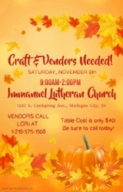
🎨 Calling All Crafters!
We are hosting a Craft Fair on Saturday, November 8, from 9:00 a.m. to 2:00 p.m.
in our Fellowship Hall.
We’re currently seeking talented artisans and creative individuals to showcase their handmade goods and unique creations. If you or someone you know would like to participate, we’d love to hear from you!
To register or for more details, contact Lori Dobkins at 219-575-1506
A FLYER IS ON FPC’S BULLETIN BOARD BY THE GARDEN DOOR

† † †
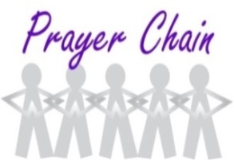

For prayer requests
Contact Brian Spiece at
jspiece@hotmail.com

† † †

Rev. Dr. Ericka Parkinson Kilbourne
Mobile – 219-380-6566
Office – 219-879-4501 Ext 203
Fax – 219-879-4503
E-mail erickapk@fpcmicity.org

† † †

Diane Yettaw, Office Administrator
Office – 219-879-4501 Ext 201
Fax – 219-879-4503
E-mail – dyettaw@fpcmicity.org

† † †

Web Site Address – http://www.fpcmicity.org
YouTube – First Presbyterian Church Michigan City
Facebook – First Presbyterian Church Michigan City
WiFi password: 1holyGod!

† † †

