**CHURCH CHAT**

“Any or all information is subject to change without notification”

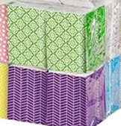

**OUTREACH NEEDS**

We are almost out of individual tissue packets. If you would like to contribute a package, please give them to the Sunday usher or any member of the Outreach committee-Michele, Judy, Marilyn, or Peggy. Thank you for your help.

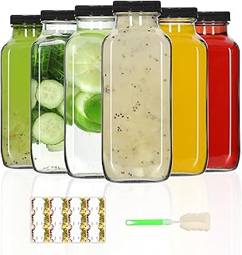**PW FOOD OF THE MONTH PROJECT**

We are collecting bottles of Italian, Ranch, and French salad dressings now until the end of September for Nest Community Shelter. Thank you for your contributions.

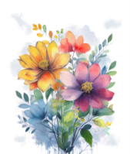**THE CHANCEL FLOWERS**

We have open dates October 5, October 12, November 9, and November 23. If you are interested in any of these dates, please contact the office. The cost is $35.00.

Thank you.

**HELP NEEDED WITH COFFEE HOUR**

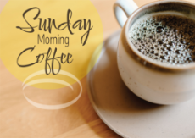Our 2025 Coffee Hour sign-up chart is posted on the Edith Boyd Lounge door, ready for you along with your family, friends, or committee to pick a date to sponsor coffee hour. Remember, it doesn’t have to be extravagant. Coffee, a drink for the kids, and a treat is all that’s needed. Most of the year is covered by the Women’s Circles, Deacons, and the Mission Committee but every other third Sunday and the fifth Sundays need volunteers. It would be really great if one group would volunteer for all the 5th Sundays, there are 4. If you are willing to do this, see Jeanette Tyrrell. In the meantime, please consider serving your fellow congregants by signing up for a coffee hour Sunday.



**IMMANUEL LUTHERAN CHURCH**

🎨 **Calling All Crafters!**  
 We are hosting a **Craft Fair** on **Saturday, November 8**, from **9:00 a.m. to 2:00 p.m.**

in our Fellowship Hall.

We’re currently seeking talented artisans and creative individuals to showcase their handmade goods and unique creations. If you or someone you know would like to participate, we’d love to hear from you!

To register or for more details, contact Lori Dobkins at 219-575-1506

**A FLYER IS ON THE BULLETIN BOARD BY THE GARDEN DOOR**