CHURCH CHAT
“Any or all information is subject to change without notification”

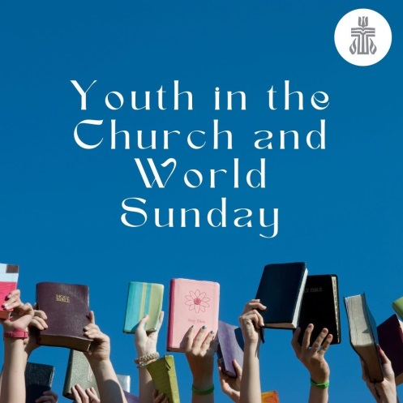

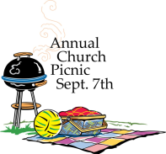



ALL CHURCH ANNUAL PICNIC
As we all know “time flies”, so be sure to mark your calendar for our annual picnic on September 7th. You won’t want to miss this one!! More details will be released after the August 17th Deacons meeting.
We will also be welcoming Pastor Ericka and her family back from sabbatical.
The sign-up sheet for food is located on the door of the Edith Boyd Lounge.

OUTREACH NEEDS
We are almost out of individual tissue packets. If you would like to contribute a package, please give them to the Sunday usher or any member of the Outreach committee-Michele, Judy, Marilyn, or Peggy. Thank you for your help.


THE CHANCEL FLOWERS
We have open dates August 17, August 24, August 31, October 5, October 12, November 9, and November 23. If you are interested in any of these dates, please contact the office. The cost is $35.00. Thank you.

2025 TX Hill Country Flooding
Forms are on the usher’s table and will be emailed with the weekly bulletins.

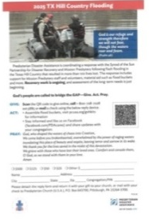



Our 2025 Coffee Hour sign-up chart is posted on the Edith Boyd Lounge door, ready for you along with your family, friends, or committee to pick a date to sponsor coffee hour. Remember, it doesn’t have to be extravagant. Coffee, a drink for the kids, and a treat is all that’s needed. Most of the year is covered by the Women’s Circles, Deacons, and the Mission Committee but every other third Sunday and the fifth Sundays need volunteers. It would be really great if one group would volunteer for all the 5th Sundays, there are 4. If you are willing to do this, see Jeanette Tyrrell. In the meantime please consider serving your fellow congregants by signing up for a coffee hour Sunday.

FEATURED ARTIST
Artist, Diane Grams earned a BA in Fine Art (1981) at Indiana University Bloomington where she studied under Chicago artist Robert Barnes; and a Master’s degree (2001) and PhD (2004) in cultural sociology at Loyola University Chicago where she was awarded a Schmidt Dissertation Fellowship for her research into Chicago art networks. She is an author of two academic books: Producing Local Color: Art Networks In Ethnic Chicago (University of Chicago Press 2010) and Entering Cultural Communities: Diversity and Change in the Nonprofit Arts (Rutgers University Press, 2008) and the award winning academic article, Freedom and Cultural Consciousness: Black Working Class Parades in Post-Katrina New Orleans. (Journal of Urban Affairs, 2013) She is married to photographer Timothy D. Lace. They live in northwest Indiana where they share Somersault Studio 12, a studio in St. Mary’s Studios, a former elementary school in Michigan City, IN.
Be sure to visit the Edith Boyd Lounge to witness her artwork and read more about Diane.
If you are interested, most of her pieces on display are for sale. There are eight prints of various sizes located on the table outside of the library that are “cash & carry” for $20 each. If you would like to purchase one, please bring it into the office along with your payment. Thank you.

MICHIGAN CITY CHAMBER MUSIC FESTIVAL
First Presbyterian Church will be hosting the MCCMF again this year. There is a list as to when and what area of the church they will be using in August along with concert dates on the bulletin board outside the Edith Boyd Lounge. If you need more information, please visit their website at www.mccmf.org. Thank you.

MICHIGAN CITY MESSIAH
Hallelujah Gala will be on Saturday, September 20, 2025 at the Senior Center located at 2 On The Lake, Michigan City, IN. For details, see the flyer on the bulletin board outside the Edith Boyd Lounge or visit MCMessiah.com or tickets@mcmessiah.com. Tickets go on sale August 1.

† † †
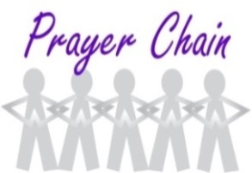

For prayer requests
Contact Brian Spiece at
jspiece@hotmail.com

† † †

Rev. Dr. Ericka Parkinson Kilbourne
Mobile – 219-380-6566
Office – 219-879-4501 Ext 203
Fax – 219-879-4503
E-mail erickapk@fpcmicity.org

† † †

Diane Yettaw, Office Administrator
Office – 219-879-4501 Ext 201
E-mail – dyettaw@fpcmicity.org

† † †

Web Site Address – http://www.fpcmicity.org
YouTube – First Presbyterian Church Michigan City
Facebook – First Presbyterian Church Michigan City
WiFi password: 1holyGod!

† † †

