**CHURCH CHAT**

“Any or all information is subject to change without notification”

**PENTECOST LABYRINTH WALK**

For the last several years we have gathered at the Friendship Botanic Gardens to celebrate Pentecost.  We meet after church at 12:30 and bring our lunch and then walk the labyrinth.

Please come this Sunday, June 8th and join in this special gathering.  The cost for admittance is $10, seniors $7 and children are free.

**OUTREACH NEEDS**

**Tissue:** We are almost out of individual tissue packets. If you would like to contribute a package please give them to the Sunday usher or any member of the Outreach committee-Michele, Judy, Marilyn, or Peggy. Thank you for your help.

**PW COLLECTION**

PW will be collecting coffee and presweetened Kool-Aide or lemonade powdered drink mix for Nest Community Shelter until the end of June. Any questions see Carol Garrett. Thank you.

**FEATURED ARTIST**

Be sure to come to the Edith Boyd Lounge to witness the artwork of our dear sister Barbara Vinson.  Her artwork is a reflection of God's handiwork and the ways in which Barbara used her talent to share love and beauty.  You will not want to miss this particular display in the Edith Boyd Lounge.

**COFFEE HOUR SIGN UP**

r Sign-Up

Our 2025 Coffee Hour sign-up chart is posted on the Edith Boyd Lounge

door, ready for you along with your family, friends, or committee to pick a

date to sponsor coffee hour. Remember, it doesn't have to be extravagant.

Coffee, a drink for the kids, and a treat is all that's needed. Most of the year

is covered by the Women's Circles, Deacons, and the Mission Committee but

every other third Sunday and the fifth Sundays need volunteers. It would be

really great if one group would volunteer for all the 5

th

Sundays, there are 4.

If you are willing to do this, see Jeanette Tyrrell. In the mean time please

consider serving your fellow congregants by signing up for a coffee hour

Sun

Our 2025 Coffee Hour sign-up chart is posted on the Edith Boyd Lounge door, ready for you along with your family, friends, or committee to pick a date to sponsor coffee hour. Remember, it doesn’t have to be extravagant. Coffee, a drink for the kids, and a treat is all that’s needed. Most of the year is covered by the Women’s Circles, Deacons, and the Mission Committee but every other third Sunday and the fifth Sundays need volunteers. It would be really great if one group would volunteer for all the 5th Sundays, there are 4. If you are willing to do this, see Jeanette Tyrrell. In the meantime please consider serving your fellow congregants by signing up for a coffee hour Sunday.

**THE CHANCEL FLOWERS**

If you are interested, as of now, we have open dates on June 29, July 6, July 20, July 27, August 17, August 24, August 31, October 5, October 19, November 9 and November 30. If you are interested in any of these dates, please contact the office. The cost is $35.00. Thank you.

25 Coffee Hour sign-up chart is posted on the Edith Boyd Lounge

door, ready for you along with your family, friends, or committee to pick a

date to sponsor coffee hour. Remember, it doesn't have to be extravagant.

Coffee, a drink for the kids, and a treat is all that's needed. Most of the year

is covered by the Women's Circles, Deacons, and the Mission Committee but

every other third Sunday and the fifth Sundays need volunteers. It would be

really great if one group would volunteer for all the 5

th

Sundays, there are 4.

If you are willing to do this, see Jeanette Tyrrell. In the mean time please

consider serving your fellow congregants by signing up for a coffee hour

Sun

**BLOOD PRESSURE SCREENING**

Beginning June 15th and continuing every third Sunday each month, Mary Barr will be doing blood pressure screening in the library after Worship and before coffee hour. You do not have to sign up, just show up. Remember, it is best NOT to drink coffee or eat before you have your pressure checked.

If you have any questions, please see Mary Barr. Thank you.

**PRIDE FEST**

For several years, thanks to the spearheading and committed effort by Anne Lute First Presbyterian Church has been represented at the Michigan City Pride Fest and we are once again going to be represented at this event which is being held next Saturday, June 14, down at Washington Park. We will be sharing giveaways, accepting prayer requests from attendees and talking about our church to those who have questions. If you are out at the park next Saturday stop by our booth and say hi.

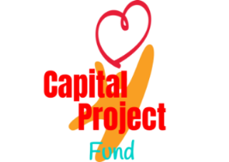

We reached our goal for the elevator campaign but If you are interested in purchasing a brick, there is still time. The link is no longer live but you can complete the “blue” form that is located by the garden doors. Please turn your completed form(s) along with the $100.00 per brick to Diane in the office. The bricks will be placed into the Heritage Garden at a later date.

Future sales of the bricks will now go into our Capital Project Fund to use for any future “big projects”. Thank you for your generosity!

**SAVE THE DATE JULY 11-12**

**REGISTRATION FORMS ARE ON THE USHER’S TABLE**

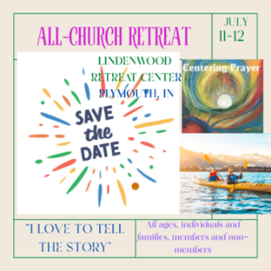A link was also emailed to all to register on line. If you have any questions about registration, please contact Andrew Grove.

**IMMANUEL LUTHERAN CHURCH Vacation Bible School**

IMMANUEL LUTHERAN CHURCH, Michigan City, invites children ages 4–11 (or just completed 5th grade) to join us at our Vacation Bible School program, **Wonder Junction, June 23-27, 8:30-11:30 a.m., at 1237 E. Coolspring Ave, Michigan City *(at the corner of Woodland & Coolspring Aves.)*.**  There’s no greater joy than to praise the name of the Lord all day long.  But how can your kids do that if they don’t know who Jesus is or what He’s done for them?  Here at *Wonder Junction*, kids will discover the wonder of who Jesus is as we travel through the Old West while marveling at Jesus' birth, childhood, ministry, death and resurrection, and coming return.  **Pre-registration is recommended.  You can register online at immanuelmc.com or call the office at 219-872-4419.  One form is needed for EACH child.**

† † †

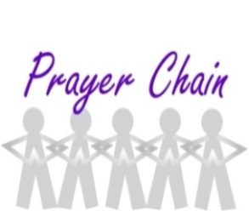

For prayer requests

Contact Brian Spiece at

[jspiece@hotmail.com](mailto:jspiece@hotmail.com)

† † †

Rev. Dr. Ericka Parkinson Kilbourne

Mobile – 219-380-6566

Office – 219-879-4501 Ext 203

Fax – 219-879-4503

E-mail [erickapk@fpcmicity.org](mailto:erickapk@fpcmicity.org)

† † †

Diane Yettaw, Office Administrator

Office – 219879-4501 Ext 201

E-mail – [dyettaw@fpcmicity.org](mailto:dyettaw@fpcmicity.org)

† † †

Web Site Address – <http://www.fpcmicity.org>

YouTube – First Presbyterian Church Michigan City

Facebook – First Presbyterian Church Michigan City

WiFi password: 1holyGod!

† † †

