***CHURCH* CHAT**

(Any or all information is subject to change without notification)

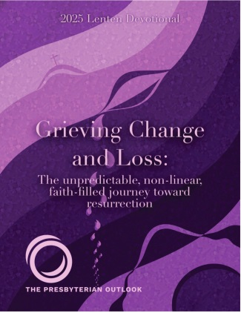**2025 LENTEN DEVOTIONAL**

“For everything there is a season and a time for every matter under heaven: A time to be born and a time to die; a time to plant and a time to pluck up what is planted; a time to kill and a time to heal; a time to break down and a time to build up; a time to weep and a time to laugh; a time to mourn and a time to dance,” (Ecclesiastes 3:1-4)

This spring, Pastor Ericka is hosting a Grief Group, which will meet twice a month on Sundays, after worship. Whether your grief is new or has been for many years, whether you are grieving a loved one or a situation, our God offers compassion through scripture, prayer, and through conversation with others.  If you would like to join and attend, please speak with Janice Casper, Brock Vinson, or Pastor Ericka.

**The CHANCEL FLOWERS**

If you are interested, as of now, we have some open dates March 30th and April 6th.

It is possible there will be more dates in later months and those will be posted at a later date. If you normally have an annual date those are automatically reserved for you and will be the same as past years unless you contact me to make a change. If you did not pay last year, we will assume you are not interested and your date will be opened to others. The cost is $35.00.

If you have any questions, please contact the office. Thank you.

**Coffee Hour Sign-Up**

Our 2025 Coffee Hour sign-up chart is posted on the Edith Boyd Lounge door, ready for you along with your family, friends, or committee to pick a date to sponsor coffee hour. Remember, it doesn't have to be extravagant. Coffee, a drink for the kids, and a treat is all that's needed. Most of the year is covered by the Women's Circles, Deacons, and the Mission Committee but every other third Sunday and the fifth Sundays need volunteers. It would be really great if one group would volunteer for all the 5th Sundays, there are 4. If you are willing to do this, see Jeanette Tyrrell. In the meantime please consider serving your fellow congregants by signing up for a coffee hour Sunday.

Coffee Hour Sign-Up

Our 2025 Coffee Hour sign-up chart is posted on the Edith Boyd Lounge

door, ready for you along with your family, friends, or committee to pick a

date to sponsor coffee hour. Remember, it doesn't have to be extravagant.

Coffee, a drink for the kids, and a treat is all that's needed. Most of the year

is covered by the Women's Circles, Deacons, and the Mission Committee but

every other third Sunday and the fifth Sundays need volunteers. It would be

really great if one group would volunteer for all the 5

th

Sundays, there are 4.

If you are willing to do this, see Jeanette Tyrrell. In the mean time please

consider serving your fellow congregants by signing up for a coffee hour

Sun

**Presbyterian Coffee Project Relaunch!**

[](https://shop.equalexchange.coop/)[](https://pcusa.org/about-pcusa/agencies-entities/interim-unified-agency/ministry-areas/hunger-program/sustainable-livingearth-care-concerns/fair-trade-coffee-project)The Mission Committee is excited to relaunch the *Presbyterian Coffee Project* through the Equal Exchange program! This **Fair Trade** initiative ensures that small-scale farmers receive fair prices, work in safe conditions, and sustain their communities. By choosing Fair Trade coffee, you’re supporting ethical practices that align with our faith values. (Scan the QR code below)!

*“Speak out, judge righteously, and defend the rights of the poor and needy.” —Proverbs 31:9*

**BUILDING/ROOM USE FORMS**

If your organization, committee, etc. use the church for your meetings or functions, please submit your completed form for 2025 to the office by February 28th. If your updated form is not received, we will assume you no longer need to use the building and will make your date, time and room available to others. Also, if your Certificate of Liability Insurance has expired, we will need a current copy.

If you have any questions, please contact the office. Thank you.



* March 2 Sunday 9 a.m. Adult Ed
* March 2 Sunday 10 a.m. Worship service Transfiguration of the Lord
* March 2 Sunday Communion Sunday
* March 3 Monday PASTOR OFF
* March 4 Tuesday 10 a.m. - 11 a.m. 3B ( through March 27)
* March 4 Tuesday 11 a.m.-1 p.m. Wednesday Circle
* March 4 Tuesday 2 p.m. Personnel meeting
* March 4 Tuesday 6 p.m. Finance meeting
* March 5 Wednesday 10:30 a.m. Bible Study
* March 5 Wednesday 4:30 p.m. B&G meeting
* **March 5** **Wednesday 5 p.m. Ash Wednesday Service (Lent begins)**
* March 6 Thursday 10 a.m. - 11 a.m. 3B ( through March 27)
* March 6 Thursday 12 p.m. PEO Chapter BA meeting in the Edith Boyd Lounge
* March 6 Thursday 5:30 p.m. Girl Scouts meeting
* March 7 Friday Office Closed **Pastor in by appointment**
* March 8 Saturday 11:30 a.m.- 1:00 p.m. Soup Kitchen
* March 9 Sunday 9 a.m. Adult Ed
* March 9 Sunday 10 a.m. Worship service 1st Sunday in Lent
* March 9 Sunday Teens meet after worship
* March 10 Monday PASTOR OFF
* March 11 Tuesday 10 a.m. - 11 a.m. 3B ( through March 27)
* March 12 Wednesday 10 a.m. Outreach meeting
* March 12 Wednesday 10:30 a.m. Bible Study
* March 12 Wednesday 12:00 p.m. Wednesday Circle meeting
* March 13 Thursday 10 a.m. - 11 a.m. 3B ( through March 27)
* March 13 Thursday 4:30 p.m. Mission meeting (Hybrid)
* March 14 Friday Office Closed **Pastor in by appointment**
* March 15 Saturday 11:30 a.m.- 1:00 p.m. Soup Kitchen
* March 16 Sunday 9 a.m. Adult Ed
* March 16 Sunday 10 a.m. Worship service 2nd Sunday in Lent
* **March 17 Monday St. Patrick’s Day**
* March 17 Monday PASTOR OFF

**LENTEN DEVOTIONAL**



The Outreach committee has a few extra Lenten Devotionals remaining from the bags we prepare for our senior at-home members. If you would like to purchase this little booklet for your own season of Lent, please see Michele Bartels or Peggy McAnally at church with $2.00 in hand.

First come, first served.



Dear members and friends,

Last Saturday, our team walked along with 112 walkers for the 5k CNOY (“Coldest Night of the Year”) event in Michigan City. Collectively, we raised $766! Deacon Lauren White, was awarded the “Sub-Zero Hero” Award because of how much money she raised and how prepared she dressed up (ask her about it)! Lauren raised a total of $575. Because of this opportunity, we were able to provide support to the Nest Community Shelter which altogether will receive $24,454 (117% of their goal of raising $20,000). We want to thank the following: Lauren White, Jennifer Casper, and Rylie Thornton for taking the courageous walk, and Sue Ransom, Mel Ledgerwood, and Pastor Ericka Kilbourne for seeing us off with their prayers and moral support. Finally, we extend our deepest appreciation to any of you who have financially contributed to this effort and cause!

Until next year,

Mission Committee



**ELEVATOR FUND CAMPAIGN**

As of February 24h, here are the numbers:

* We anticipate the final cost of the project is going to come in around $142,000 (about 8K under the original budget).
* We have raised $117,789 (includes a $50K grant).

In order to avoid dipping into our savings, we are still looking to raise an additional $25,000.

Please continue to donate to the elevator fund, and/or buy a brick or two for our heritage garden. Bricks are $100.00 each and can be purchased via this link. You can also pick up a paper form at the display by the garden door or contact Diane for one.

[**https://form.jotform.com/241926284623157**](https://form.jotform.com/241926284623157)

**Thank you for your generosity!**

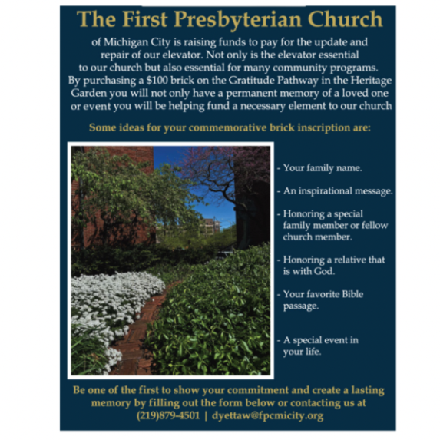

† † †

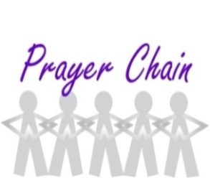

For prayer requests

Contact Brian Spiece at

[jspiece@hotmail.com](mailto:jspiece@hotmail.com)

† † †

Rev. Dr. Ericka Parkinson Kilbourne

Mobile – 219-380-6566

Office – 219-879-4501 Ext 203

Fax – 219-879-4503

E-mail [erickapk@fpcmicity.org](mailto:erickapk@fpcmicity.org)

† † †

Diane Yettaw, Office Administrator

Office – 219879-4501 Ext 201

E-mail – [dyettaw@fpcmicity.org](mailto:dyettaw@fpcmicity.org)

† † †

Web Site Address – <http://www.fpcmicity.org>

YouTube – First Presbyterian Church Michigan City

Facebook – First Presbyterian Church Michigan City

WiFi password: 1holyGod!

† † †

