***CHURCH* CHAT**

(Any or all information is subject to change without notification)

**ELEVATOR UPDATE**



We still have to get the new carpet installed and walls repaired in the basement landings, but please use it as needed. Pay attention to weight limits when bringing in heavy items.

Thank you for your patience and please continue your donations and the brick walkway fundraiser to cover the completion cost.

Thanks again, Building & Grounds

**PW GIVING PROJECT**

Please bring boxes of cold cereal for the men and women in the overnight shelter on 8th Street. We will collect with love until the end of February. Thank you.

**Join Pastor Ericka and others** for this exciting in-depth exploration of the Gospel of Mark!

Wednesdays 10:30 a.m.-11:30 a.m. in the Library



**3RD SUNDAY PROGRAM: EXPLORING OUR COMMUNITY, EXPANDING OUR MISSION**

Our next guest speaker is Marguerite Havard, executive director of Last Bell Ministries—U.S. Team since 2024. Marguerite is no stranger to our congregation—raised in this church and daughter of Andy & Janice Casper, we are proud of her ministry leadership supporting Ukrainian orphans. Join us in welcoming Marguerite back on **February 16**, following worship in the Edith Boyd Lounge. Light refreshments and fair trade coffee will be served.

**FEATURED ARTISTS**

We have “new” art work displayed in the Edith Boyd Lounge; the work of Andre Daugavietis and Scott Saporiti. Please take a moment to view their work and read a bit about each of them

.

nd Barb Vinson has had health issues for quite some time and is

recuperating at Regency Hospital in Portage. She is ready for visitors, two at

a time, and we hope some of you will be able to make the trip to Portage to

spend some time with her. The address is Northwest Health,

3630 Willowcreek Road, Portage, 46368. Regency, where she is staying, is

on the third floor and she is in room 3308. Also, if any of you would be

available to sit with Barb from 5 PM-8 PM on any given day so that Brock

can run errands and possibly go home for a bit he would be greatly

appreciative. See Peggy McAnally if you have questions or want directio



On **Saturday, February 22**, join us for **Coldest Night of the Year (CNOY),** an international event raising funds for local charities that support those experiencing **hurt, hunger, and homelessness**—because **it’s cold out there!**

In **Michigan City,** The Nest Community Shelter is organizing the walk. Let’s team up, fundraise, and walk together! We’ll gather at **4:00 PM at 2 On the Lake** (near the Michigan City Senior Center & Washington Park Beach).

There are **three ways to get involved:**🥾 **Walk**: [cnoy.w-ith.us/fpcmc](http://cnoy.w-ith.us/fpcmc)🤝 **Volunteer**: [cnoy.com/volunteer](http://cnoy.com/volunteer) (select "Michigan City" from the drop-down menu)  
💙 **Donate**: [cnoy.w-ith.us/fpcmc](http://cnoy.w-ith.us/fpcmc)

Let’s step up for our neighbors in need—see you there!

**Presbyterian Coffee Project Relaunch!**

[](https://shop.equalexchange.coop/)[](https://pcusa.org/about-pcusa/agencies-entities/interim-unified-agency/ministry-areas/hunger-program/sustainable-livingearth-care-concerns/fair-trade-coffee-project)The Mission Committee is excited to relaunch the *Presbyterian Coffee Project* through the Equal Exchange program! This **Fair Trade** initiative ensures that small-scale farmers receive fair prices, work in safe conditions, and sustain their communities. By choosing Fair Trade coffee, you’re supporting ethical practices that align with our faith values.

Join us at our next 3rd Sunday Program on February 16 to enjoy and purchase this high-quality coffee. Members and friends are also invited to place orders and make a difference—one cup at a time (scan the QR code below)!

*“Speak out, judge righteously, defend the rights of the poor and needy.” —Proverbs 31:9*



* Feb 16 Sunday 9 a.m. Adult Ed
* Feb 16 Sunday 10 a.m. Worship service 6th Sunday after Epiphany
* Feb 16 Sunday after worship 3rd Sunday program in the Edith Boyd Lounge
* Feb 16 Sunday 3-7 p.m. Private party in the undercroft
* Feb 17 Monday **PASTOR OFF**
* Feb 17 Monday **President’s Day** **OFFICE closed**
* Feb 18 Tuesday 10 a.m. - 11 a.m. 3B ( through March 27)
* Feb 18 Tuesday 6:30 p.m. Elizabeth Circle meeting
* Feb 19 Wednesday 10:30 a.m. “Gospel of Mark” in the library
* Feb 19 Wednesday 4 p.m. Deacon’s meeting
* Feb 19 Wednesday 6:30 p.m. Session meeting
* Feb 20 Thursday 10 am- 11 a.m. 3B ( through March 27)
* Feb 20 Thursday 5:30 pm Girl Scout meeting
* Feb 21 Friday Office Closed **Pastor in by appointment**
* Feb 22 Saturday 9:30 a.m. Faith Formation Bible Study
* Feb 22 Saturday 11:30 a.m.- 1:00 p.m. Soup Kitchen
* Feb 23 Sunday 9 a.m. Adult Ed
* Feb 23 Sunday 10 a.m. Worship service 7th Sunday after Epiphany
* Feb 23 Sunday 4 p.m. MCCMF scholarship meeting
* Feb 24 Monday **PASTOR OFF**
* Feb 25 Tuesday 10 a.m. - 11 a.m. 3B ( through March 27)
* Feb 26 Wednesday 10:30 a.m. “Gospel of Mark” in the library
* Feb 27 Thursday 10 a.m. - 11 a.m. 3B ( through March 27)
* Feb 28 Friday Office Closed **Pastor in by appointment**
* March 01 Saturday 11:30 a.m.- 1:00 p.m. Soup Kitchen
* March 02 Sunday 9 a.m. Adult Ed
* March 02 Sunday 10 a.m. Worship service Transfiguration of the Lord
* March 03 Monday **PASTOR OFF**



**THE ELEVATOR IS RUNNING AGAIN!**

As of February 13th, here are the numbers:

* We anticipate the final cost of the project is going to come in around $142,000 (about 8K under the original budget).
* We have raised $118,928 (includes a $50K grant).

In order to avoid dipping into our savings, we are still looking to raise an additional $25,000.

Please continue to donate to the elevator fund, and/or buy a brick or two for our heritage garden. Bricks are $100.00 each and can be purchased via this link. You can also pick up a paper form at the display by the garden door or contact Diane for one.

[**https://form.jotform.com/241926284623157**](https://form.jotform.com/241926284623157)

**Thank you for your generosity!**

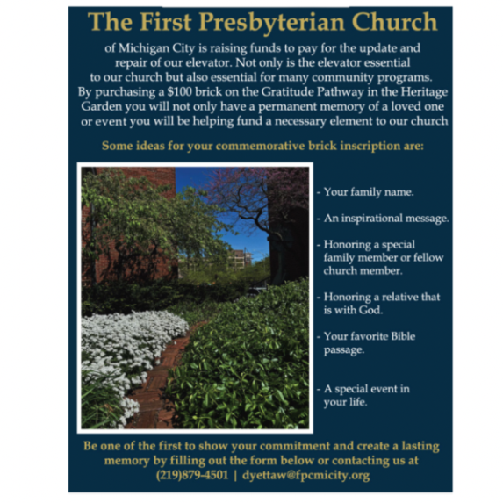

† † †



For prayer requests

Contact Brian Spiece at

[jspiece@hotmail.com](mailto:jspiece@hotmail.com)

† † †

Rev. Dr. Ericka Parkinson Kilbourne

Mobile – 219-380-6566

Office – 219-879-4501 Ext 203

Fax – 219-879-4503

E-mail [erickapk@fpcmicity.org](mailto:erickapk@fpcmicity.org)

† † †

Diane Yettaw, Office Administrator

Office – 219879-4501 Ext 201

E-mail – [dyettaw@fpcmicity.org](mailto:dyettaw@fpcmicity.org)

† † †

Web Site Address – <http://www.fpcmicity.org>

YouTube – First Presbyterian Church Michigan City

Facebook – First Presbyterian Church Michigan City

WiFi password: 1holyGod!

† † †

