***CHURCH* CHAT**

(Any or all information is subject to change without notification)

**ANNUAL REPORT**

The annual report is due soon. The last day to submit your report is

**January 9, 2024**. This will allow time for the report to be created and printed for distribution on January 19th. Thank you.

**2025 PER CAPITA**

The per capita for 2025 is $44.66 per person

The breakdown is as follows: Synod of Lincoln Trails: $3.81 General Assembly: $10.84

Wabash Valley: $30.01



**STEWARDSHIP**

Thank you to all who attended Stewardship Sunday. The finance team appreciates your generosity. The pledges help us create our budget for next year. If you weren't able to attend or have lost your pledge card and still want to pledge, you can email Diane your pledge or use this link to pledge on-line --which is easy for everyone. Thank you again

riend Barb Vinson has had health issues for quite some time and is

recuperating at Regency Hospital in Portage. She is ready for visitors, two at

a time, and we hope some of you will be able to make the trip to Portage to

spend some time with her. The address is Northwest Health,

3630 Willowcreek Road, Portage, 46368. Regency, where she is staying, is

on the third floor and she is in room 3308. Also, if any of you would be

available to sit with Barb from 5 PM-8 PM on any given day so that Brock

can run errands and possibly go home for a bit he would be greatly

appreciative. See Peggy McAnally if you have questions or want directio



**“Stewards of Children” Training TODAY**

“Stewards of Children” training on January 5, 2025 at 11:30 a.m. until 2 p.m. This is a free training offered to us by Dunebrook. All officers (Elders and Deacons) and anyone planning to teach Sunday school or chaperone a

children or youth outing or event is asked to come.



**ELEVATOR OUT OF SERVICE UNTIL FURTHER NOTICE**

* Jan 05 Sunday 9 a.m. Adult Ed – “Caring for God’s creation”
* Jan 05 Sunday 10 a.m. Worship service-2nd Sunday of Christmas Communion Sunday
* Jan 05 Sunday 11:30 a.m. -2:00 p.m. Stewards of Children Training
* Jan 06 Monday Epiphany
* Jan 06 Monday **PASTOR OFF**
* Jan 07 Tuesday 10 am- 11 a.m. 3B New Session through March 27
* Jan 07 Tuesday 2 pm Personnel meeting in the library
* Jan 07 Tuesday 6 p.m. Finance meeting
* Jan 07 Tuesday 6 p.m. PFLAG
* Jan 08 Wednesday 4:30 p.m. Building & Grounds meeting
* Jan 08 Wednesday 10 a.m. Outreach meeting
* Jan 08 Wednesday 12 p.m. Wednesday Circle meeting
* Jan 09 Thursday 10 am- 11 a.m. 3B (through March 27)
* Jan 10 Friday Office Closed **Pastor in by appointment**
* Jan 11 Saturday 11:30 a.m.- 1:00 p.m. Soup Kitchen
* Jan 12 Sunday 9 a.m. Adult Ed – “Caring for God’s creation”
* Jan 12 Sunday 10 a.m. Worship service-Baptism of the Lord
* Jan 12 Sunday after worship Teens & Tweens meet
* Jan 13 Monday **PASTOR OFF**
* Jan 14 Tuesday 10 am- 11 a.m. 3B New Session through March 27
* Jan 15 Wednesday 4 pm Deacon’s meeting
* Jan 16 Thursday 10 am- 11 a.m. 3B New Session through March 27
* Jan 17 Friday Office Closed **Pastor in by appointment**
* Jan 18 Saturday 11:30 a.m.- 1:00 p.m. Soup Kitchen



**ELEVATOR BRICK FUNDRAISER**

For over fifty years, our heritage garden has been a resurrection symbol of new life and of welcome, as each spring its buds peek up from the ground, even after the harshest of winters. In all seasons, it is the place where our visitors enter our building for the first time.  
The garden's brick path will soon represent the confident hope that, with a refurbished elevator, we will continue to tell the resurrection story to ALL. Each contribution to the brick fundraiser will be directed to our elevator fund. The cost is $100.00 per brick. With this link, you are invited to enter the words you would like to be written on your brick. You may choose to make your payment online, or you can bring or send your check to First Presbyterian Church, 121 W 9th St. Michigan City, IN 46360.

[**https://form.jotform.com/241926284623157**](https://form.jotform.com/241926284623157)

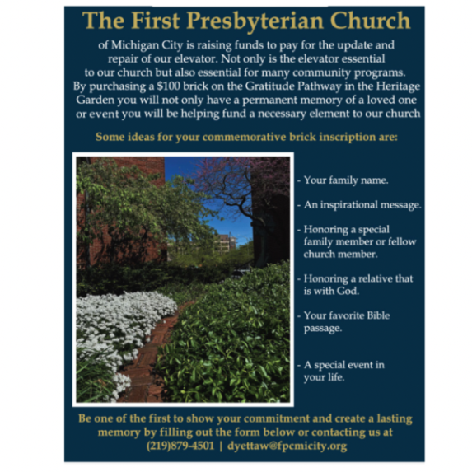

**ELEVATE OUR WELCOME**

**CURRENT STATUS OF OUR ELEVATOR FUND CAMPAIGN**

**TARGET**: $150,000.00 (100%)

**CONGREGATION GIFTS ACHIEVED** $64,670.00 (42.7%)

**GRANT**$50,000.00 (33.3%)

**ACHIEVED WITH GRANT** $114,670.00 (76%)

**The elevator work is coming to an end and payments will need to be made.**

**Remember, this project will come in around $150,000. So if you haven’t fulfilled**

**your pledge, or would like to give to this project, please turn in your gifts to the office soon and note that they are for the elevator project. Thank you so much**!

† † †



For prayer requests

Contact Brian Spiece at

[jspiece@hotmail.com](mailto:jspiece@hotmail.com)

† † †

Rev. Dr. Ericka Parkinson Kilbourne

Mobile – 219-380-6566

Office – 219-879-4501 Ext 103

Fax – 219-879-4503

E-mail [erickapk@fpcmicity.org](mailto:erickapk@fpcmicity.org)

† † †

Diane Yettaw, Office Administrator

Office – 219879-4501 Ext 101

E-mail – [dyettaw@fpcmicity.org](mailto:dyettaw@fpcmicity.org)

† † †

Web Site Address – <http://www.fpcmicity.org>

YouTube – First Presbyterian Church Michigan City

Facebook – First Presbyterian Church Michigan City

WiFi password: 1holyGod!

† † †

