Barbara Reichert

Jan 29 Craig Molden

Jan 31 Michael Smith

Jan 31 Michele Smith

Feb 01 Debbie Langley

Feb 01 Carrie Zerbe

***CHURCH* CHAT**

(Any or all information is subject to change without notification)

**2025 PER CAPITA**

The per capita for 2025 is $44.66 per person

The breakdown is as follows: Synod of Lincoln Trails: $3.81 General Assembly: $10.84

Wabash Valley: $30.01



**STEWARDSHIP**

Thank you to all who attended Stewardship Sunday. The finance team appreciates your generosity. The pledges help us create our budget for next year. If you weren't able to attend or have lost your pledge card and still want to pledge, you can email Diane your pledge or use this link to pledge on-line --which is easy for everyone. Thank you again

riend Barb Vinson has had health issues for quite some time and is

recuperating at Regency Hospital in Portage. She is ready for visitors, two at

a time, and we hope some of you will be able to make the trip to Portage to

spend some time with her. The address is Northwest Health,

3630 Willowcreek Road, Portage, 46368. Regency, where she is staying, is

on the third floor and she is in room 3308. Also, if any of you would be

available to sit with Barb from 5 PM-8 PM on any given day so that Brock

can run errands and possibly go home for a bit he would be greatly

appreciative. See Peggy McAnally if you have questions or want directio



Join Pastor Ericka and others for this exciting in-depth exploration of the Gospel of Mark!

Wednesdays 10:30 a.m.-11:30 a.m. in the Library

**PW GIVING PROJECT**

Please bring boxes of cold cereal for the men and women in the overnight shelter on 8th Street. We will collect with love until the end of February. Thank you.

**First United Methodist Church**

We received notice from the United Women in Faith that they have decided to postpone their annual Valentine Tea until next year on February 14, 2026.



**FOOD ITEM OF THE MONTH**

We have recently been requesting donations of food supply items to stock our inventory. Many of you have graciously and generously donated plastic silverware, biodegradable plates, and cups. These contributions help us offset the costs of purchasing supplies, allowing us to keep our Soup Kitchen Fund sustainable.

Now that our inventory of supplies is looking good, we are shifting our focus to food donations. For January, the “food item of the month” is canned fruits. As usual, please drop your donated goods on the table in the narthex near the coat racks.

*“The fruit of the Spirit is love, joy, peace, patience, kindness, goodness, faithfulness, gentleness, and self-control. There is no law against things like this.” —Galatians 5:22-23*



**ELEVATOR OUT OF SERVICE UNTIL FURTHER NOTICE**

* Jan 26 Sunday 9 a.m. Adult Ed – “Caring for God’s creation”
* Jan 26 Sunday 10 a.m. Worship service-3rd Sunday after Epiphany
* Jan 26 Sunday **NO CHILDREN’S SUNDAY SCHOOL**
* Jan 26 Sunday Congregational meeting after worship
* Jan 27 Monday **PASTOR OFF**
* Jan 28 Tuesday 10 am- 11 a.m. 3B ( through March 27)
* Jan 29 Wednesday 10:30 a.m. “Gospel of Mark” in the library
* Jan 30 Thursday10 am- 11 a.m. 3B ( through March 27)
* Jan 31 Friday Office Closed **Pastor in by appointment**
* Feb 01 Saturday 11:30 a.m.- 1:00 p.m. Soup Kitchen
* Feb 02 Sunday 9 a.m. Adult Ed
* Feb 02 Sunday 10 a.m. Worship service-4th Sunday after Epiphany
* Feb 03 Monday **PASTOR OFF**
* Feb 04 Tuesday 10 a.m. - 11 a.m. 3B ( through March 27)
* Feb 04 Tuesday 2 p.m. Personnel meeting
* Feb 04 Tuesday 6 p.m. Finance meeting
* Feb 04 Tuesday 6 p.m. PFLAG
* Feb 05 Wednesday 10:30 a.m. “Gospel of Mark” in the library
* Feb 05 Wednesday 10 a.m. Outreach meeting
* Feb 05 Wednesday 12 p.m. Wednesday Circle meeting
* Feb 06 Thursday 10 am- 11 a.m. 3B ( through March 27)
* Feb 06 Thursday 4:30 pm Building & Grounds meeting
* Feb 06 Thursday 4:30 pm Mission meeting (Hybrid)
* Feb 06 Thursday 5:30 pm Girl Scout meeting
* Feb 07 Friday Office Closed **Pastor in by appointment**
* Feb 08 Saturday 11:30 a.m.- 1:00 p.m. Soup Kitchen
* Feb 09 Sunday 9 a.m. Adult Ed
* Feb 09 Sunday 10 a.m. Worship service-5th Sunday after Epiphany
* Feb 10 Monday **PASTOR OFF**



**ELEVATOR BRICK FUNDRAISER**

For over fifty years, our heritage garden has been a resurrection symbol of new life and of welcome, as each spring its buds peek up from the ground, even after the harshest of winters. In all seasons, it is the place where our visitors enter our building for the first time.  
The garden's brick path will soon represent the confident hope that, with a refurbished elevator, we will continue to tell the resurrection story to ALL. Each contribution to the brick fundraiser will be directed to our elevator fund. The cost is $100.00 per brick. With this link, you are invited to enter the words you would like to be written on your brick. You may choose to make your payment online, or you can bring or send your check to First Presbyterian Church, 121 W 9th St. Michigan City, IN 46360.

[**https://form.jotform.com/241926284623157**](https://form.jotform.com/241926284623157)

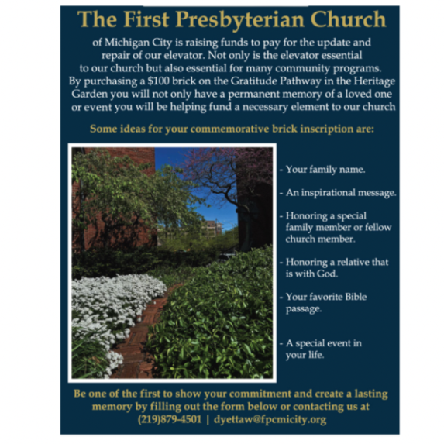

**ELEVATE OUR WELCOME**

**CURRENT STATUS OF OUR ELEVATOR FUND CAMPAIGN**

**TARGET**: $150,000.00 (100%)

**CONGREGATION GIFTS ACHIEVED** $66,709.00 (44.7%)

**GRANT**$50,000.00 (33.3%)

**ACHIEVED WITH GRANT** $116,709.00 (78%)

**The elevator work is coming to an end and payments will need to be made.**

**Remember, this project will come in around $150,000. So if you haven’t fulfilled**

**your pledge, or would like to give to this project, please turn in your gifts to the office soon and note that they are for the elevator project. Thank you so much**!

† † †



For prayer requests

Contact Brian Spiece at

[jspiece@hotmail.com](mailto:jspiece@hotmail.com)

† † †

Rev. Dr. Ericka Parkinson Kilbourne

Mobile – 219-380-6566

Office – 219-879-4501 Ext 103

Fax – 219-879-4503

E-mail [erickapk@fpcmicity.org](mailto:erickapk@fpcmicity.org)

† † †

Diane Yettaw, Office Administrator

Office – 219879-4501 Ext 101

E-mail – [dyettaw@fpcmicity.org](mailto:dyettaw@fpcmicity.org)

† † †

Web Site Address – <http://www.fpcmicity.org>

YouTube – First Presbyterian Church Michigan City

Facebook – First Presbyterian Church Michigan City

WiFi password: 1holyGod!

† † †

