***CHURCH* CHAT**

(Any or all information is subject to change without notification)

**STEWARDSHIP**

Thank you to all who attended Stewardship Sunday. The finance team appreciates your generosity. The pledges help us create our budget for next year. If you weren't able to attend or have lost your pledge card and still want to pledge, you can email Diane your pledge or use this link to pledge on-line --which is easy for everyone. Thank you again

r friend Barb Vinson has had health issues for quite some time and is

recuperating at Regency Hospital in Portage. She is ready for visitors, two at

a time, and we hope some of you will be able to make the trip to Portage to

spend some time with her. The address is Northwest Health,

3630 Willowcreek Road, Portage, 46368. Regency, where she is staying, is

on the third floor and she is in room 3308. Also, if any of you would be

available to sit with Barb from 5 PM-8 PM on any given day so that Brock

can run errands and possibly go home for a bit he would be greatly

appreciative. See Peggy McAnally if you have questions or want directio



**“Stewards of Children” Training**

“Stewards of Children” training on January 5, 2025 at 11:30 a.m. until 2 p.m. This is a free training offered to us by Dunebrook. All officers (Elders and Deacons) and anyone planning to teach Sunday school or chaperone a children or youth outing or event is asked to come.



**ELEVATOR OUT OF SERVICE UNTIL FURTHER NOTICE**

* Dec 08 Sunday 9 a.m. Adult Ed – “Do Not Fear”
* Dec 08 Sunday 10 a.m. Worship service 2nd Sunday of Advent
* Dec 08 Sunday Teens and Tweens meet after worship
* Dec 09 Monday **PASTOR OFF**
* Dec 10 Tuesday 6 p.m. Finance meeting
* Dec 11 Wednesday 10 a.m. Outreach meeting
* Dec 11 Wednesday 12 p.m. Wednesday Circle meeting
* Dec 13 Friday Office Closed **Pastor in by appointment**
* Dec 14 Saturday 11:30 a.m.- 1:00 p.m. Soup Kitchen
* Dec 15 Sunday 9 a.m. Adult Ed – “Do Not Fear”
* Dec 15 Sunday 10 a.m. Worship service-3rd Sunday of Advent
* Dec 15 Sunday Church Pageant
* Dec 16 Monday **PASTOR OFF**
* Dec 17 Tuesday 6:30 p.m. Elizabeth Circle meeting
* Dec 18 Wednesday 4 p.m. Deacon’s meeting
* Dec 19 Thursday 5:30 p.m. PEO BR in Edith Boyd Lounge
* Dec 19 Thursday 5:30 p.m. until 7 p.m. Girl Scouts meeting in undercroft
* Dec 20 Friday Office Closed **Pastor in by appointment**
* Dec 21 Saturday 11:30 a.m.- 1:00 p.m. Soup Kitchen
* Dec 21 Saturday 6 p.m. Longest Night Service
* Dec 22 Sunday 9 a.m. Adult Ed – “Do Not Fear”
* Dec 22 Sunday 10 a.m. Worship service-4th Sunday of Advent
* Dec 23 Monday **PASTOR OFF**
* Dec 24 Tuesday Office Closed Christmas Eve
* Dec 24 Tuesday 5 p.m. Christ Eve Service
* Dec 25 Wednesday Office closed **MERRY CHRISTMAS**
* Dec 26 Thursday Office Closed Christmas Holiday
* Dec 27 Friday Office Closed
* Dec 28 Saturday 9:30 a.m. Faith Formation Bible Study
* Dec 28 Saturday 11:30 a.m.- 1:00 p.m. Soup Kitchen
* Dec 29 Sunday 9 a.m. Adult Ed – “Do Not Fear”
* Dec 29 Sunday 10 a.m. Worship service 1st Sunday of Christmas
* Dec 30 Monday **PASTOR OFF**
* Dec 31 Tuesday Office Closed New Year’s Eve
* Jan 01 Wednesday Office Closed New Year’s Day **HAPPY NEW YEAR 2025**

Dear Congregation members,

Your session elders met on December 4th (very windy and cold evening!) to hold our regular November/December meeting.

Here are some highlights of the meeting:

*Pastor Kevin Bowers was our special guest speaker.  Pastor Kevin provided our session with details of our own Elder Jose Soto's preparation for ministry.

*Our treasurer Amy McDaniel, along with the chair of the Finance committee, Rob McFarland updated us on the current state of our financial situation as well as insight into the future.  The bottom line is we need more members to pledge and more money needs to come in to pay our expenses to run the church.

*For those of you inquiring when a memorial will be held for our dear sister Barb Vinson, it will be held in March.  Date and time to be determined in the near future.

*There were several building requests that were approved by session.  The MC Chamber Music on 2/9/25; MC Chamber Music Festival in August 2025; PFLAG group for their monthly meetings in the Edith Boyd Lounge; Girl Scout troop in December 2024.

*Elder Mark Smith notified the session that there has been several delays in the completion of the elevator.  Elder Smith did not have a fixed time of completion but he is working with the company and trying to push them to give us a time frame for completion.

*Elder Jose Soto made a motion which was approved for the upcoming Christmas Joy Offering.

*Liturgists for December will be:  Rob McFarland-12/8; Laura Kittle 12/15; Michele Bartels 12/22; and Rob McFarland on 12/29/24.

*Session approved the motion to endorse Elder Jose Soto's request to enroll as an Inquirer in preparation for his ministry formation. We are so pleased to be able to support Jose in his desire to become a Pastor and preach the word of God, as well as minister to those in need.  God bless you Jose!!

Our next meeting will be on December 18th.  Please continue to pray for your Pastor and the elders in session, as well as the deacons who are serving our congregation and the community.  We all greatly need and appreciate the prayers and support.

In Christ we can do great things!

Laura Kittle

Clerk of Session

**ELEVATOR BRICK FUNDRAISER**

For over fifty years, our heritage garden has been a resurrection symbol of new life and of welcome, as each spring its buds peek up from the ground, even after the harshest of winters. In all seasons, it is the place where our visitors enter our building for the first time.  
The garden's brick path will soon represent the confident hope that, with a refurbished elevator, we will continue to tell the resurrection story to ALL. Each contribution to the brick fundraiser will be directed to our elevator fund. The cost is $100.00 per brick. With this link, you are invited to enter the words you would like to be written on your brick. You may choose to make your payment online, or you can bring or send your check to 121 W 9th Street Michigan City, IN 46360 .

[**https://form.jotform.com/241926284623157**](https://form.jotform.com/241926284623157)

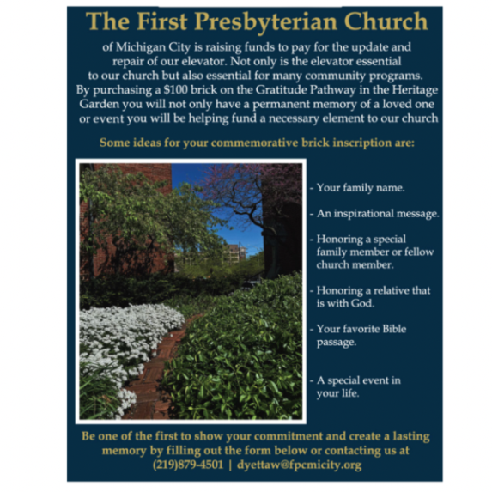



**ELEVATE OUR WELCOME**

**CURRENT STATUS OF OUR ELEVATOR FUND CAMPAIGN**

**TARGET**: $150,000.00 (100%)

**CONGREGATION GIFTS ACHIEVED** $60,660.00 (39.7%)

**GRANT**$50,000.00 (33.3%)

**ACHIEVED WITH GRANT** $110,660.00 (74%)

**The elevator work is coming to an end and payments will need to be made.**

**Remember, this project will come in around $150,000. So if you haven’t fulfilled**

**your pledge, or would like to give to this project, please turn in your gifts to the office soon and note that they are for the elevator project. Thank you so much**!

**FOOD SUPPLY ITEM OF THE MONTH**

We are collecting biodegradable hot/cold 8 oz. cups throughout December. You may drop off your in-kind donation on a table located in the Narthex area near the coat racks. Monetary donations are also welcome to the “Soup Kitchen Fund.” Thank you!

*I assure you that whoever gives you a cup of water to drink because you belong to Christ will certainly be rewarded. —Mark 9:41 (CEB)*

**MESSIAH CONCERT**

This year all activities will be at St. Mary, Immaculate Conception located at 10th & Buffalo Streets, Michigan City, Indiana on December 14th and December 15th. There is a flyer on the bulletin board with more information. You can also visit their website at MCMessiah.org

**2024 Per Capita**

As we all know time is flying by and 2024 is nearing the end. If you have not paid your 2024 Per Capita, there is still time. The amount is $43.62 per person. If you have any questions, please contact the office. Thank you.

**ADVANCE NOTICE OF 2025 PER CAPITA**

2025 Per Capita $44.66

The breakdown is as follows: Synod of Lincoln Trails: $3.81 General Assembly: $10.84

Wabash Valley: $30.01



.

God has blessed the Church with incredible leadership in every time and place, but those leaders often need to be supported by their communities as well. This Offering addresses the support needed by some of our leaders, including supporting leadership development for communities of color, and providing support for Presbyterian church workers in their time of need.

+++

### $1.1 million in gifts since 2022

are being used to provide critical financial support and grants for current and retired Presbyterian church workers in their times of need;

+++

### 272 individuals helped

assisted retired church workers and surviving spouses;

+++

### 223 recipients

could afford to stay in their homes, assisted living, or long-term care;

+++

### 621 Emergency Assistant Grants

helped people facing economic hardship.

* Mail “Christmas Joy Offering”
* Web [www.presbyterianmission.org/christmasjoy](http://www.presbyterianmission.org/christmasjoy)
* Text CHRISTMASJOY to 91999

† † †



For prayer requests

Contact Brian Spiece at

[jspiece@hotmail.com](mailto:jspiece@hotmail.com)

† † †

Rev. Dr. Ericka Parkinson Kilbourne

Mobile – 219-380-6566

Office – 219-879-4501 Ext 103

Fax – 219-879-4503

E-mail [erickapk@fpcmicity.org](mailto:erickapk@fpcmicity.org)

† † †

Diane Yettaw, Office Administrator

Office – 219879-4501 Ext 101

E-mail – [dyettaw@fpcmicity.org](mailto:dyettaw@fpcmicity.org)

† † †

Web Site Address – <http://www.fpcmicity.org>

YouTube – First Presbyterian Church Michigan City

Facebook – First Presbyterian Church Michigan City

WiFi password: 1holyGod!

† † †

