CHURCH CHAT
(Any or all information is subject to change without notification)


STEWARDSHIP
Thank you to all who attended Stewardship Sunday. The finance team appreciates your generosity. The pledges help us create our budget for next year. If you weren't able to attend or have lost your pledge card and still want to pledge, you can email Diane your pledge or use this link to pledge on-line --which is easy for everyone. Thank you again



r friend Barb Vinson has had health issues for quite some time and is
recuperating at Regency Hospital in Portage. She is ready for visitors, two at
a time, and we hope some of you will be able to make the trip to Portage to
spend some time with her. The address is Northwest Health,
3630 Willowcreek Road, Portage, 46368. Regency, where she is staying, is
on the third floor and she is in room 3308. Also, if any of you would be
available to sit with Barb from 5 PM-8 PM on any given day so that Brock
can run errands and possibly go home for a bit he would be greatly
appreciative. See Peggy McAnally if you have questions or want directio

“Stewards of Children” Training
“Stewards of Children” training on January 5, 2025 at 11:30 a.m. until 2 p.m. This is a free training offered to us by Dunebrook. All officers (Elders and Deacons) and anyone planning to teach Sunday school or chaperone a
children or youth outing or event is asked to come.

2024 Per Capita
As we all know time is flying by and 2024 is nearing the end. If you have not paid your 2024 Per Capita, there is still time. The amount is $43.62 per person. If you have any questions, please contact the office. Thank you.

MESSIAH CONCERT
This year all activities will be at St. Mary, Immaculate Conception located at 10th & Buffalo Streets, Michigan City, Indiana on December 14th and December 15^{th.} There is a flyer on the bulletin board with more information. You can also visit their website at MCMessiah.org


FOOD SUPPLY ITEM OF THE MONTH
We are collecting biodegradable hot/cold 8 oz. cups throughout December. You may drop off your in-kind donation on a table located in the Narthex area near the coat racks. Monetary donations are also welcome to the “Soup Kitchen Fund.” Thank you!
I assure you that whoever gives you a cup of water to drink because you belong to Christ will certainly be rewarded. —Mark 9:41 (CEB)


SERVICE OF THE LONGEST NIGHT
Elders Anne Lute and Jose Soto will co-lead this year’s Longest Night Service on Saturday, December 21, at 6:00 PM in the sanctuary. Our worship theme is “Finding Light in the Darkness.” Often called a “Blue Christmas” service in other churches, this gathering provides a safe and sacred space for anyone seeking hope and healing in the midst of hurt. During the service, all will be welcome to participate in meaningful ways, including lighting memory candles to honor loved ones and receive prayers for healing and wholeness with anointing.
You are not alone—we journey together—toward hope and light. *In honor and respect for this solemn gathering, the service will not be recorded or live-streamed.


ELEVATOR OUT OF SERVICE UNTIL FURTHER NOTICE

- Dec 15 Sunday 9 a.m. Adult Ed – “Do Not Fear”
- Dec 15 Sunday 10 a.m. Worship service- Church Pageant-3rd Sunday of Advent
- Dec 16 Monday PASTOR OFF
- Dec 17 Tuesday 6:30 p.m. Elizabeth Circle meeting
- Dec 18 Wednesday 4 p.m. Deacon’s meeting
- Dec 19 Thursday 5:30 p.m. PEO BR in Edith Boyd Lounge
- Dec 19 Thursday 5:30 p.m. until 7 p.m. Girl Scouts meeting in undercroft
Dec 20 Friday Office Closed Pastor in by appointment
- Dec 21 Saturday 11:30 a.m.- 1:00 p.m. Soup Kitchen
- Dec 21 Saturday 6 p.m. Longest Night Service (Worship Leaders, Anne Lute & Jose Soto)
- Dec 22 Sunday 9 a.m. Adult Ed – “Do Not Fear”
- Dec 22 Sunday 10 a.m. Worship service-4th Sunday of Advent
- Dec 23 Monday PASTOR OFF
- Dec 24 Tuesday Office Closed Christmas Eve
- Dec 24 Tuesday 5 p.m. Christmas Eve Service
- Dec 25 Wednesday Office closed MERRY CHRISTMAS
- Dec 26 Thursday Office Closed Christmas Holiday
- Dec 27 Friday Office Closed
- Dec 28 Saturday 9:30 a.m. Faith Formation Bible Study
- Dec 28 Saturday 11:30 a.m.- 1:00 p.m. Soup Kitchen
- Dec 29 Sunday NO Adult Ed
- Dec 29 Sunday 10 a.m. Worship service 1st Sunday of Christmas (Worship Leader, Anne Lute)
- Dec 30 Monday PASTOR OFF
- Dec 31 Tuesday Office Closed New Year’s Eve
- Jan 01 Wednesday Office Closed New Year’s Day HAPPY NEW YEAR 2025
- Jan 03 Friday Office Closed Pastor in by appointment
- Jan 04 Saturday 11:30 a.m.- 1:00 p.m. Soup Kitchen
- Jan 05 Sunday 9 a.m. Adult Ed – “Do Not Fear”
- Jan 05 Sunday 10 a.m. Worship service-2nd Sunday of Christmas
- Jan 05 Sunday 11:30 a.m. -2:00 p.m. Stewards of Children Training
- Jan 06 Monday PASTOR OFF
- Jan 07 Tuesday 10 am- 11 a.m. 3B New Session through March 27


.

God has blessed the Church with incredible leadership in every time and place, but those leaders often need to be supported by their communities as well. This Offering addresses the support needed by some of our leaders, including supporting leadership development for communities of color, and providing support for Presbyterian church workers in their time of need.
+++

$1.1 million in gifts since 2022
are being used to provide critical financial support and grants for current and retired Presbyterian church workers in their times of need;
+++

272 individuals helped
assisted retired church workers and surviving spouses;
+++

223 recipients
could afford to stay in their homes, assisted living, or long-term care;
+++

621 Emergency Assistant Grants
helped people facing economic hardship.

- Mail “Christmas Joy Offering”
- Web www.presbyterianmission.org/christmasjoy
- Text CHRISTMASJOY to 91999



ELEVATOR BRICK FUNDRAISER
For over fifty years, our heritage garden has been a resurrection symbol of new life and of welcome, as each spring its buds peek up from the ground, even after the harshest of winters. In all seasons, it is the place where our visitors enter our building for the first time.
The garden's brick path will soon represent the confident hope that, with a refurbished elevator, we will continue to tell the resurrection story to ALL. Each contribution to the brick fundraiser will be directed to our elevator fund. The cost is $100.00 per brick. With this link, you are invited to enter the words you would like to be written on your brick. You may choose to make your payment online, or you can bring or send your check to First Presbyterian Church, 121 W 9th St. Michigan City, IN 46360.

https://form.jotform.com/241926284623157

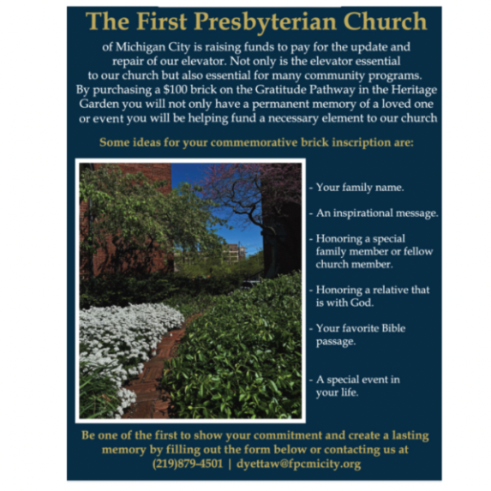

ELEVATE OUR WELCOME

CURRENT STATUS OF OUR ELEVATOR FUND CAMPAIGN

TARGET: $150,000.00 (100%)
CONGREGATION GIFTS ACHIEVED $61,160.00 (39.7%)
GRANT $50,000.00 (33.3%)
ACHIEVED WITH GRANT $111,160.00 (74%)

The elevator work is coming to an end and payments will need to be made.
Remember, this project will come in around $150,000. So if you haven’t fulfilled
your pledge, or would like to give to this project, please turn in your gifts to the office soon and note that they are for the elevator project. Thank you so much!

† † †


For prayer requests
Contact Brian Spiece at
jspiece@hotmail.com

† † †

Rev. Dr. Ericka Parkinson Kilbourne
Mobile – 219-380-6566
Office – 219-879-4501 Ext 103
Fax – 219-879-4503
E-mail erickapk@fpcmicity.org

† † †

Diane Yettaw, Office Administrator
Office – 219879-4501 Ext 101
E-mail – dyettaw@fpcmicity.org

† † †

Web Site Address – http://www.fpcmicity.org
YouTube – First Presbyterian Church Michigan City
Facebook – First Presbyterian Church Michigan City
WiFi password: 1holyGod!

† † †

