Church CHAT for Sept 19th
Best Wishes For a very hAPPY DAY

September 01 Alice Yacullo
September 02 Pat Bracken
September 02 Elizabeth Choate
September 02 Stephanie Livingston Nfr
September 06 Anne Beatty
September 07 Amy Alexander
September 08 Bud Ogle
September 09 Pat Molden
September 09 Linda Wilson
September 10 Michael Hoffman
September 11 David Wilson
September 13 Jeanette Tyrrell
September 14 Jeff Thorne
September 15 Sandy Dougherty
September 16 David Miller
September 17 Annabelle Kilbourne
September 17 Jerry Kilbourne
September 17 Maxine Schwartz
September 21 Sarah Jones
September 24 Jacob Luncsford
September 24 Nora Mosher
September 26 F. Scott Winfield
September 28 Marilyn Cook
September 28 Louise Durflinger
September 30 Marc Russell
September 30 Eva Wolff

2021 PER CAPITA
Per Capita for 2021 is $42.03 per person. Remember this should NOT be included in your check for regular offering because it goes into a dedicated fund. Thank you

CAR SHOW FUNDRAISER
Please join us at First Methodist Church, 121 E. 7th Street, Michigan City, Indiana from 10am-2pm on September 25 for a car show to help Erik Tannehill, director of the downtown soup kitchen, with medical expenses. See enclosed flyer

MASKS
The Session, by recommendation of the COVID response team of the First Presbyterian Church of Michigan City has made the decision that MASKS ARE REQUIRED AT ALL TIMES WHILE YOU ARE IN THE BUILDING, EVEN IF YOU ARE FULLY VACCINATED.
FOR THE HEALTH AND SAFETY OF ALL PLEASE WEAR A MASK
AND CONTINUE TO OBSERVE DISTANCING
We would like for all to feel safe and comfortable when they worship with us. Thank You.

CELEBRATE!

AS OF TODAY, WE HAVE ACHIEVED 28% OF OUR GOAL
To carry on the celebration of the 150th birthday of First Presbyterian Church in Michigan City, we are continuing our 150-150-150 stewardship celebration plan.

- Goal: to raise $22,500 to ensure a fully funded budget, since a deficit is forecasted for 2021.
- Plan: 150 church members contribute $150 over and above their pledge or regular giving.
- Deadline: We continue to welcome any additional payments you wish to make throughout 2021.
Please direct your check to the office or use the PayPal link. Be sure to indicate in the memo or in an email (dyettaw@fpcmicity.org) that your contribution is for the 150-150-150
Each week, the progress toward the goal for 150-150-150 will be reported in the bulletin and through email, text, social media, and on the church website (www.fpcmicity.org)

MEDITATION FELLOWSHIP
Do you want to meditate but you don’t know how? Is your life confused? Is your prayer life non-existent or noisy? Do you want to become closer to Christ?

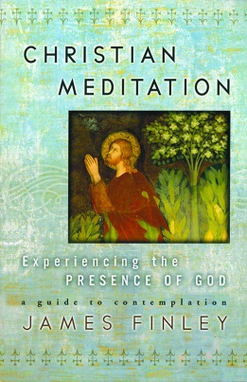
Christian Meditation is an ancient tradition brought into the new church. To begin our study in meditation, we begin on our knees as Christ taught us to meditate when we pray. To meditate is to enter the mind of Christ in freely choosing to realize our oneness with the Christ the Word’s oneness with the Father. Meditation practice is a way of opening ourselves to this graced realization of this oneness with God that is the very person that we are.

Please join us on Wednesdays at 10am starting August 18th
Come dressed comfortably.
Rev. Kevin Patterson, Order of St. Luke

FINANCE REPORT

.
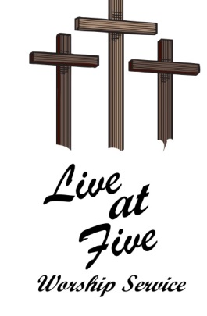
“LIVE AT FIVE” Worship Service
Sunday, September 26th in the Sanctuary at 5pm
If you have any questions, please contact Pastor Ericka

The Food TaskForce
Much of our local mission efforts involve food - food preparation, food storage, food distribution, food delivery. This all adds up to a lot of packing, unpacking, carrying, lifting and just plain schlepping. Right now, all this work is being done by two or three people. They could really use some HELP! This would involve short-term commitments of an hour or two on any given project.

Here are just a few of the tasks that need some helping hands:
- Receive and unload deliveries of food from Food Bank (every 4-6 weeks) and food rescue groups (usually weekly).
- Pack and deliver emergency food boxes to neighbors (as needed)
- Help our dear Blanche - “Carte Blanche” - fill Blanche’s shopping cart with surplus items from our pantry to share with members of our congregation (weekly)
- Identify and contact families in need, and offer help.

If you can help fight hunger in our community, PLEASE sign up. Sheets will be posted in the church, or call Janice Casper (219 204-0494) or Debbie Langley (219 874-6326) for more information.

!!!POSTPONEMENT!!!!

Due to rising COVID numbers in LaPorte County, Session has voted to postpone Rally Sunday. In-person Worship will still take place, but we will not be following the sermon topics until we are ready to start as an entire group. A new date will be announced as soon as it is known. Until then, hold onto your reflection guide (if you ordered one) and we will use them just as soon as it is safe!

With this delay, this gives you another chance to order a “Follow Jesus” reflection guide if you didn’t have a chance the first time.

Please use this link to reserve your $8.00 copy https://forms.gle/HnAUDV7gcygxYEhU6
(This can also be found on Facebook) or scan this bar code:

Let’s Get this Party Staaaarted!
In the next few weeks Outreach, as part of our 150th Year Celebration, will sponsor the sale of Presbyterian logo shirts for adults and children. Join the jubilee and sport one of these shirts. Show that you are loud and proud of the 150-year tradition of this amazing church in our community! We will also be offering an extremely interesting historical record of our first 125 years, written by members Doris and Albert Wendt and collated by Pat Molden. The shirts will be $12 for adults and $6 for children. “A Church History” is $10. Stay tuned for further details.

ATTENTION WEDNESDAY AND ELISABETH CIRCILES
The 2021-2022 BIBLE study guides are in. Nancy Arnold will be collecting your money and handling them out before and after worship service beginning September 19th.

FOR THOSE WHO HAVE PAID, YOUR FIRST GUIDE CAN BE PICKED UP ON SUNDAY BEFORE WORSHIP FROM THE USHER

